# Instructional Guide to Support 2023 Algebra 2 *Standards of Learning*



Copyright © 2025

by the

Virginia Department of Education

P.O. Box 2120

Richmond, Virginia 23218-2120

[http://www.doe.virginia.gov](http://doe.virginia.gov/)

All rights reserved. Reproduction of these materials for instructional purposes in public school classrooms in Virginia is permitted.

**Superintendent of Public Instruction**

Emily Anne Gullickson, M.Ed. J.D.

**Office of Math and Science**

Dr. Anne Petersen, Director of Math and Science

Dr. Angela Byrd-Wright, Director of Humanities (Former Mathematics Coordinator)

Ms. Victoria Bohidar, Mathematics Coordinator

Dr. Jessica Brown, Elementary Mathematics Specialist

Dr. Regina Mitchell, Mathematics and Special Education Specialist

Mrs. Donna Snyder, Mathematics Division Support Specialist

**NOTICE**

The Virginia Department of Education does not unlawfully discriminate on the basis of race, color, sex, national origin, age, or disability in employment or in its educational programs or services.

Table of Contents

Introduction 3

Understanding the Standard 3

Skills in Practice 3

Concepts and Connections 3

Expressions and Operations 4

A2.EO.1 4

A2.EO.2 8

A2.EO.3 13

A2.EO.4 22

Equations and Inequalities 25

A2.EI.1 25

A2.EI.2 32

A2.EI.3 37

A2.EI.4 43

A2.EI.5 48

A2.EI.6 53

Functions 58

A2.F.1 58

A2.F.2 67

Statistics 84

A2.ST.1 84

A2.ST.2 95

A2.ST.3 103

## Introduction

The Mathematics Instructional Guide, a companion document to the 2023 Mathematics *Standards of Learning*, amplifies the Standards of Learning by defining the core knowledge and skills in practice, supporting teachers and their instruction, and serving to transition classroom instruction from the 2016 *Mathematics Standards of Learning* to the newly adopted 2023 Mathematics *Standards of Learning.* Instructional supports are accessible in #GoOpenVA and support the decisions local school divisions must make concerning local curriculum development and how best to help students meet the goals of the standards. The local curriculum should include a variety of information sources, readings, learning experiences, and forms of assessment selected at the local level to create a rigorous instructional program.

For a complete list of the changes by standard, the [2023 Virginia Mathematics *Standards of Learning – Overview of Revisions*](https://www.doe.virginia.gov/home/showpublisheddocument/49329/638325360068970000) is available and delineates in greater specificity the changes for each grade level and course.

The Instructional Guide is divided into three sections: Understanding the Standard, Skills in Practice, and Concepts and Connections aligned to the Standard. The purpose of each is explained below.

### Understanding the Standard

This section includes mathematics understandings and key concepts that assist teachers in planning standards-focused instruction. The statements may provide definitions, explanations, or examples regarding information sources that support the content. They describe what students should know (core knowledge) as a result of the instruction specific to the course/grade level and include evidence-based practices to approaching the Standard. There are also possible misconceptions and common student errors for each standard to help teachers plan their instruction.

### Skills in Practice

This section outlines supporting questions and skills that are specifically linked to the standard. They frame student inquiry, promote critical thinking, and assist in learning transfer. Curriculum writers and teachers should use them to plan instruction to deepen understanding of the broader unit and course objectives. This is not meant to be an exhaustive list of student expectations.

### Concepts and Connections

This section outlines concepts that transcend grade levels and thread through the K through 12 mathematicsprogram as appropriate at each level. Concept connections reflect connections to prior grade-level concepts as content and practices build within the discipline as well as potential connections across disciplines.

# Algebra 2

## Expressions and Operations

Expressions and operations comprise the foundation for algebraic thinking, understanding, and application. Students use expressions and operations to develop and solve equations, inequalities, and functions. These skills unpack building blocks that are necessary for advanced mathematical thinking, understanding, and application. Also, mastery of performing operations on expressions is required for higher level mathematics courses.

Throughout Algebra 2, students will perform operations on rational and radical expressions. Additionally, students will factor polynomial expressions and perform operations on complex numbers.

### A2.EO.1

##### The student will perform operations on and simplify rational expressions.

1. Students will demonstrate the following Knowledge and Skills:
2. Add, subtract, multiply, or divide rational algebraic expressions, simplifying the result.
3. Justify and determine equivalent rational algebraic expressions with monomial and binomial factors. Algebraic expressions should be limited to linear and quadratic expressions.
4. Recognize a complex algebraic fraction and simplify it as a product or quotient of simple algebraic fractions.
5. Represent and demonstrate equivalence of rational expressions written in different forms.

###### Understanding the Standard

* An expression is a representation of a quantity that may contain numbers, variables, or operation symbols (e.g., $x, -\sqrt[4]{54}, 3^{\frac{1}{2}}+2m$).
* A rational algebraic expression is the ratio of two polynomial expressions. Examples of rational algebraic expressions include $\frac{3x-2}{x+1}$, $\frac{x^{2}-1}{x-3}$, $\frac{5x}{x^{2}-x-6}$.
* Computational skills applicable to numerical fractions also apply to rational algebraic expressions.
* In this standard, denominators are assumed to be non-zero; however, students would benefit from learning experiences that make connections between values of the variable that would lead to having a zero in the denominator of a rational expression and domain restrictions of the corresponding rational function.
* A complex algebraic fraction is a rational algebraic expression where the numerator, denominator, or both is also a rational algebraic expression. Examples of complex algebraic fractions include $\frac{\frac{x-1}{x-2}}{x^{2}+3}$, $\frac{2x}{\frac{x^{2}-4}{x-1}}$, $\frac{\frac{x+3}{x-4}}{\frac{6x}{2x+1}}$.
* A complex algebraic fraction can be rewritten in an equivalent form as the quotient or product of simple algebraic fractions and then simplified to create an equivalent form. See the example below. Assume no denominator is equal to zero.

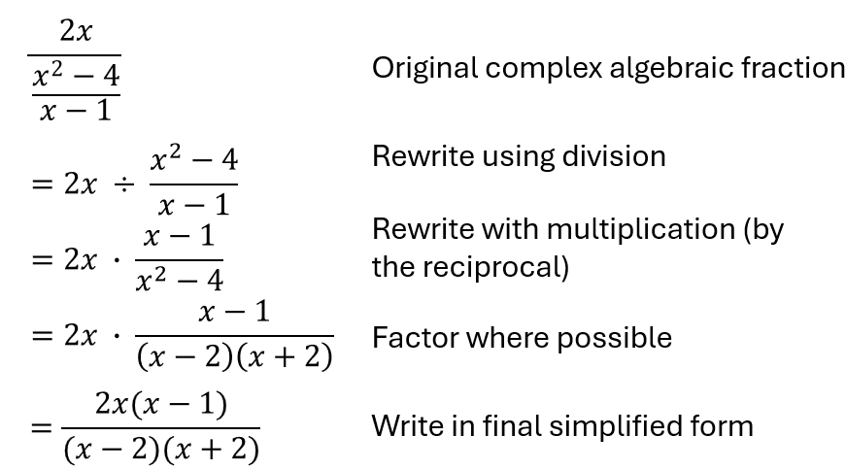

* Rewriting a rational expression in different but equivalent forms allows some aspects of the expression to be more apparent. For example, it may be easier to visualize the simplified form of a rational expression, but this may not reveal possible domain restrictions.

###### Skills in Practice

While the five process goals are expected to be embedded in each standard, the Skills in Practice highlight the most prevalent process goals in relation to the content presented.

**Mathematical Reasoning:** Students often apply incorrect reasoning when performing computations with rational algebraic expressions. Some common errors and misconceptions are listed below.

* Students may try to simplify common monomial terms from a rational algebraic expression. For example, if they simplify an expression to $\frac{(x+7)}{(x-4)}$, students may try to further simplify the expression by simplifying the common monomial term, $x$, from the numerator and the denominator, resulting in an incorrect answer of $-\frac{7}{4}$. This indicates that students do not understand that the entire binomial factor must be equivalent in order to simplify. Students would benefit from circling the entire binomial factor to help identify if there are equivalent factors. Students may also graph the related function of the original expression and then compare the graph of the related functions of the subsequent equivalent expressions to verify that all are equivalent.
* When adding rational algebraic expressions, students may demonstrate several common errors. Consider the example below. Assume that no denominator is equal to zero.

$\frac{x}{x-3}+\frac{5}{x^{2}-7x+12}$

One common error is for students to add the numerators and add the denominators, resulting in an incorrect response of $\frac{x+5}{(x-3)(x-3)(x-4)}$. Another common error is for students to add the expressions before finding a common denominator, resulting in an incorrect response of $\frac{x+5}{(x-3)(x-4)}$. Students who demonstrate these errors may need scaffolded support to include practice with simpler numerical problems (e.g., $\frac{3}{4}+\frac{2}{5})$ to help students conceptualize the process of adding fractions, and then building to practice with rational algebraic expressions that do not require factoring (e.g., $\frac{4}{x-4}+\frac{2}{x-2}$).

* Students may have difficulty when the problem requires subtraction. Consider the example below. Assume that no denominator is equal to zero.

$$\frac{x-1}{x+2}-\frac{x-2}{x^{2}-4}$$

After finding common denominators, students may incorrectly simplify the expression to $\frac{x^{2}-3x+2-x-2}{(x+2)(x-2)}$ and then simplify further to $\frac{x^{2}-4x}{(x+2)(x-2)}$. This indicates that students only subtracted the $x$*-*term and not both terms in the numerator of the second fraction. Students who demonstrate this misconception may benefit from rewriting the problem as an addition problem and distributing the negative before factoring or finding a common denominator. Students may also benefit from graphing the related function of the given expression and the related function of their simplified expression to determine if they are equivalent.

**Mathematical Connections:** Many students have difficulty dividing rational algebraic expressions. A common mistake is to rewrite the expression as a product without expressing the reciprocal of the divisor. For example, given $\frac{x^{2}-9x+20}{x-4}÷2x,$ students may incorrectly rewrite this as $\frac{x^{2}-9x+20}{x-4}∙2x$ instead of $\frac{x^{2}-9x+20}{x-4}∙\frac{1}{2x}$. This may indicate that students do not recognize that the denominator of the divisor is equal to 1, or they may not understand the connection between division and multiplication by the reciprocal. Teachers should encourage students to write the divisor with a denominator of 1 prior to rewriting the expression as a product. Additionally, students who struggle with this concept would benefit from experience with simpler problems, such as $\frac{4x^{2}}{5}÷2x$, to develop an understanding of the process of dividing rational expressions.

###### Concepts and Connections

Concepts

Rational expressions can be used to describe and define real-life contextual situations.

Connections

* *Within the grade level/course*:
  + A2.EO.2 – The student will perform operations on and simplify radical expressions.
  + A2.EO.3 – The student will perform operations on polynomial expressions and factor polynomial expressions in one and two variables.
  + A2.EO.4 – The student will perform operations on complex numbers.
* *Vertical Progression*:
  + A.EO.1 – The student will represent verbal quantitative situations algebraically and evaluate these expressions for given replacement values of the variables.
  + A.EO.2 – The student will perform operations on and factor polynomial expressions in one variable.
  + A.EO.3 – The student will derive and apply the laws of exponents.
  + A.EO.4 – The student will simplify and determine equivalent radical expressions involving square roots of whole numbers and cube roots of integers.

###### Resources to Support Local Curriculum

* A list of approved textbooks and instructional materials is posted on the VDOE [website](https://www.doe.virginia.gov/teaching-learning-assessment/k-12-standards-instruction/mathematics/2024-mathematics-textbooks).
* [EOC Algebra 2 Formula Sheet](https://www.doe.virginia.gov/home/showpublisheddocument/56035/638581953490870000)(PDF)
* [Table of Standard Normal Probabilities](https://www.doe.virginia.gov/home/showpublisheddocument/20152/638043600831870000) (*z*-table) (PDF)

### A2.EO.2

##### The student will perform operations on and simplify radical expressions.

1. Students will demonstrate the following Knowledge and Skills:
2. Simplify and determine equivalent radical expressions that include numeric and algebraic radicands.
3. Add, subtract, multiply, and divide radical expressions that include numeric and algebraic radicands, simplifying the result. Simplification may include rationalizing the denominator.
4. Convert between radical expressions and expressions containing rational exponents.

###### Understanding the Standard

* An expression is a representation of a quantity that may contain numbers, variables, or operation symbols (e.g., $x, -\sqrt[4]{54}, 3^{\frac{1}{2}}+2m$).
* A radical expression is an expression that includes a root and is written with a radical symbol. The expression under the radical symbol is called the *radicand*. The *index* of a root (also called the degree of the root) is written just outside and above the radical symbol. The index determines which root to take.

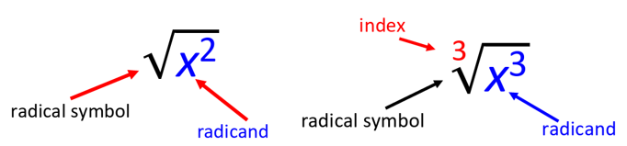

* When working with radical expressions, squaring a number and taking the square root of a number are inverse operations. Similarly, cubing a number and taking the cube root of a number are inverse operations.
* When simplifying radicals that have even indices (such as a square root), examine the radicand. If the radicand contains a monomial algebraic expression with a negative coefficient, then use the imaginary unit, $i,$ to simplify the radical completely.
* In Algebra 2, students may benefit from conversations about how techniques used to simplify square root and cube root expressions can be applied to simplify radical expressions with higher indices.
* When simplifying expressions with rational exponents, the numerator of the rational exponent should not be greater than the denominator of the rational exponent. This translates to radical expression notation as well. The power of the radicand should not be greater than the index of the radical. In either case, the expression is not written in its most simplified form.
* Only radicals with a common radicand and index can be added or subtracted, which may require writing the radical in an equivalent form using a lower base and different index. See the examples below.

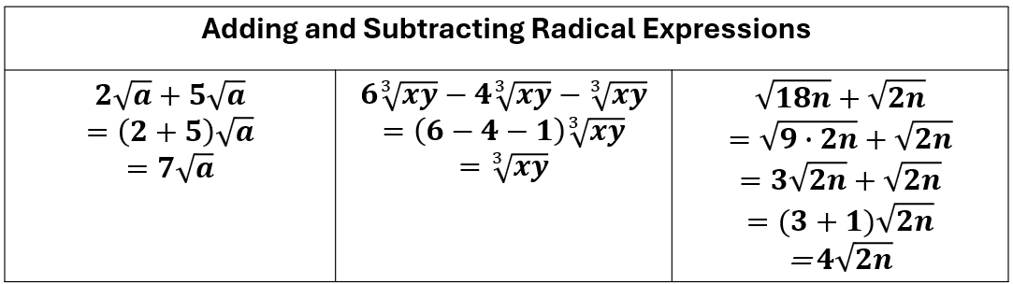

* Multiplying and dividing radical expressions containing different indices may require writing the expression in an equivalent form using rational exponents. See the examples below. Assume the variables under the radical are nonnegative. Assume no denominators are equal to zero.

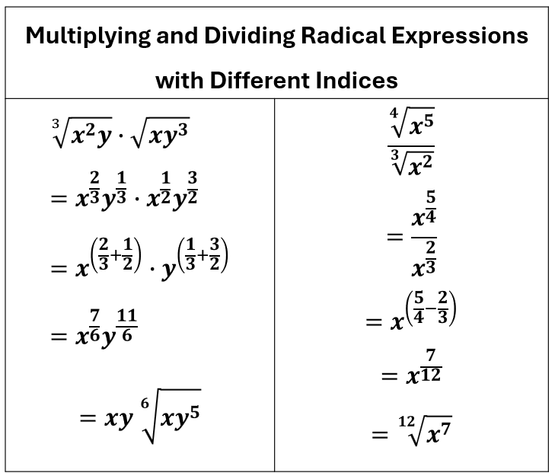

* Dividing rational expressions may require rationalizing the denominator, which is a method used to eliminate radicals from a denominator. If the denominator is a binomial with a rational term and an irrational term, the conjugate of the binomial is used to rationalize the denominator. The conjugate is an expression formed by changing the sign between the two terms (e.g., the conjugate of $\sqrt{x}+5$ is $\sqrt{x}-5$).See the examples below. Assume no denominators are equal to zero.

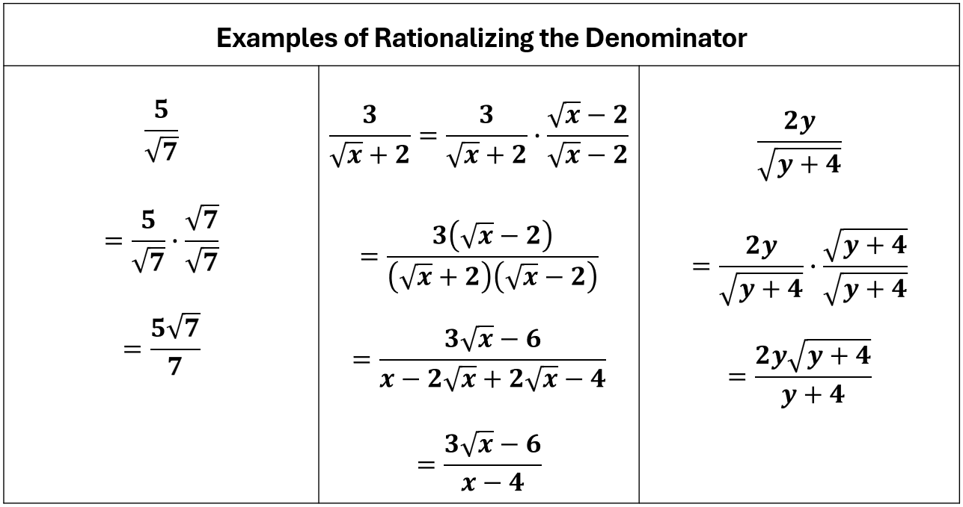

* Radical expressions can be written in an equivalent form using rational exponents (e.g., $\sqrt[3]{x^{2}}=x^{\frac{2}{3}}$ or $\sqrt{x^{3}y}=x^{\frac{3}{2}}y^{\frac{1}{2}}$).
* The Product Property of Radicals states that the $n$ th root of a product equals the product of the $n$ th roots.
  + Example: $\sqrt[n]{ab}=\sqrt[n]{a}∙\sqrt[n]{b}, a≥0 and b≥0$
  + Example: $\sqrt{5a^{3}}=\sqrt{5}∙\sqrt{a^{3}}=a\sqrt{5a}$
  + Example: $\sqrt[3]{16}=\sqrt[3]{8∙2}∙\sqrt[3]{8}∙\sqrt[3]{2}=2\sqrt[3]{2}$
* The Quotient Property of Radicals states that the $n$ th root of a quotient equals the quotient of the $n$ th roots of the numerator and denominator.
  + Example: $\sqrt[n]{\frac{a}{b}}=\frac{\sqrt[n]{a}}{\sqrt[n]{b}}, a≥0, b>0$
  + Example: $\sqrt{\frac{5}{y^{2}}}=\frac{\sqrt{5}}{\sqrt{y^{2}}}=\frac{\sqrt{5}}{y}, y≠0$
* In Algebra 2, any variables in a radical expression will be assumed to be non-negative, but students may benefit from conversations about when absolute value notation would be necessary in simplifying a radical expression.

###### Skills in Practice

While the five process goals are expected to be embedded in each standard, the Skills in Practice highlight the most prevalent process goals in relation to the content presented.

**Mathematical Reasoning:** Students often apply incorrect reasoning when working with radical expressions. Some common errors and misconceptions are listed below.

* Students may struggle when a problem requires rationalizing the denominator. Consider the example below.

$$\frac{4x+2}{\sqrt{x}-3}$$

A common error that some students may make is to multiply the given expression by $\frac{\sqrt{x}}{\sqrt{x}}$ to rationalize the denominator. This may indicate that students do not understand that rationalizing the denominator involves multiplying the numerator and denominator of the given rational expression by the conjugate of ($\sqrt{x}-3)$, which is ($\sqrt{x}+3)$. Students may find it helpful to circle the entire denominator prior to rationalizing the denominator. Additionally, students may benefit from completing simpler problems, such as $\frac{\sqrt{20x^{3}}}{\sqrt{3x}}$, as they develop an understanding of what it means to rationalize the denominator.

* Students may have difficulty when adding and subtracting radical expressions and combining like terms. Like terms must have the same index and the same radicand to be combined. For example, students may incorrectly try to add $\sqrt{x}+\sqrt[3]{x}$ because they have the same radicand. However, the first term has an index of 2 (square root), and the second term has an index of 3 (cube root). Thus, they are not like terms and cannot be combined. Similarly, students may incorrectly add $\sqrt{n}+\sqrt{5},$ obtaining a result of $\sqrt{n+5}$. However, while the two terms have the same index, they do not have the same radicand and cannot be combined.

**Mathematical Representations:** Students may make errors when working with radicals with indices greater than 2, especially when the expression is represented in radical notation. Consider the example below.

Simplify this expression: $$\sqrt[4]{256a^{7}b^{3}}$$

A common error for students is to find the square root of the expression rather than the fourth root. This may indicate that they do not understand what the index represents in a radical expression. Teachers may want to encourage students to circle the index, thus drawing attention to it. Students may also benefit from writing out the expression in expanded form and circling the same number of groups of factors that are equivalent to the value of the index. For example, the expression above could be written in expanded form as $\sqrt[4]{2∙2∙2∙2∙2∙2∙2∙2∙a∙a∙a∙a∙a∙a∙a∙b∙b∙b}$. Two groups of four 2s could be circled, one group of four *a's* could be circled, and zero groups of *b*’s could be circled, resulting in a simplified expression of $4a\sqrt[ 4]{a^{3}b^{3}}$.

###### Concepts and Connections

Concepts

Radicals are important in everyday life. Distance calculations, even GPS and map navigation software, use radicals to compute travel time.

Connections

* *Within the grade level/course*:
  + A2.EO.1 – The student will perform operations on and simplify rational expressions.
  + A2.EO.3 – The student will perform operations on polynomial expressions and factor polynomial expressions in one and two variables.
  + A2.EO.4 – The student will perform operations on complex numbers.
* *Vertical Progression*:
  + A.EO.1 – The student will represent verbal quantitative situations algebraically and evaluate these expressions for given replacement values of the variables.
  + A.EO.2 – The student will perform operations on and factor polynomial expressions in one variable.
  + A.EO.3 – The student will derive and apply the laws of exponents.
  + A.EO.4 – The student will simplify and determine equivalent radical expressions involving square roots of whole numbers and cube roots of integers.

###### Resources to Support Local Curriculum

* A list of approved textbooks and instructional materials is posted on the VDOE [website](https://www.doe.virginia.gov/teaching-learning-assessment/k-12-standards-instruction/mathematics/2024-mathematics-textbooks).
* [EOC Algebra 2 Formula Sheet](https://www.doe.virginia.gov/home/showpublisheddocument/56035/638581953490870000)(PDF)
* [Table of Standard Normal Probabilities](https://www.doe.virginia.gov/home/showpublisheddocument/20152/638043600831870000) (*z*-table) (PDF)

### A2.EO.3

##### The student will perform operations on polynomial expressions and factor polynomial expressions in one and two variables.

1. Students will demonstrate the following Knowledge and Skills:
2. Determine sums, differences, and products of polynomials in one and two variables.
3. Factor polynomials completely in one and two variables with no more than four terms over the set of integers.
4. Determine the quotient of polynomials in one and two variables, using monomial, binomial, and factorable trinomial divisors.
5. Represent and demonstrate equality of polynomial expressions written in different forms and verify polynomial identities including the difference of squares, sum and difference of cubes, and perfect square trinomials.

###### Understanding the Standard

* A polynomial is a mathematical expression consisting of variables, coefficients, and non-negative integer exponents of the variables. For example, $3x^{2}+2x-5$ and $x^{4}y^{2}+3$ are polynomials, but $5m^{n}-8$ and $n^{-3}+9$ are not polynomials (due to the variable exponent and negative exponent, respectively).
* A monomial is a polynomial with one term (e.g., $7, 6x).$ A binomial is a polynomial with two terms (e.g., $3t-1, 12xy^{3}+5xy)$. A trinomial is a polynomial with three terms (e.g., $2x^{2}+3x-7)$.
* The degree of a polynomial is the largest exponent or the largest sum of exponents of a term within a polynomial. See examples in the table below.

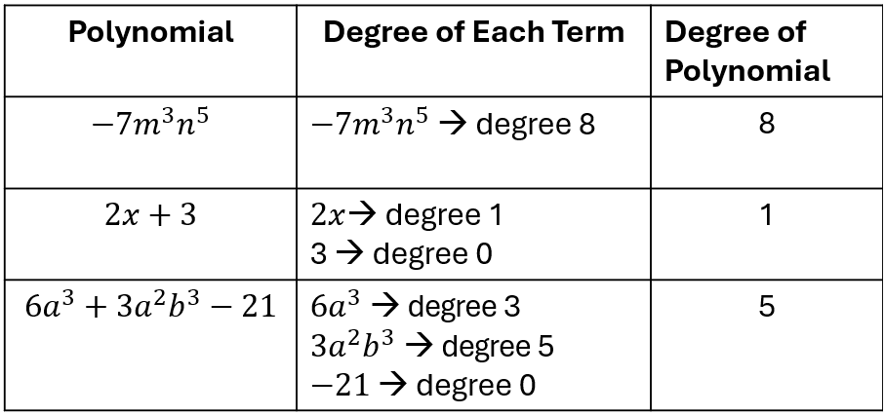

* The leading coefficient of a polynomial is the coefficient of the first term of a polynomial written in descending order of exponents.
  + $7a^{3}-2a^{2}+8a-1$ (leading coefficient is 7)
  + $-3n^{3}+7n^{2}-4n+10$ (leading coefficient is -3)
  + $16t-1$ (leading coefficient is 16)
* Operations with polynomials can be represented concretely, pictorially, and symbolically.
* Combining like terms is a method which should be employed when adding or subtracting polynomial expressions. When adding or subtracting polynomials, problems may be set up vertically or horizontally. The table below shows examples of adding and subtracting polynomials using horizontal and vertical formats.

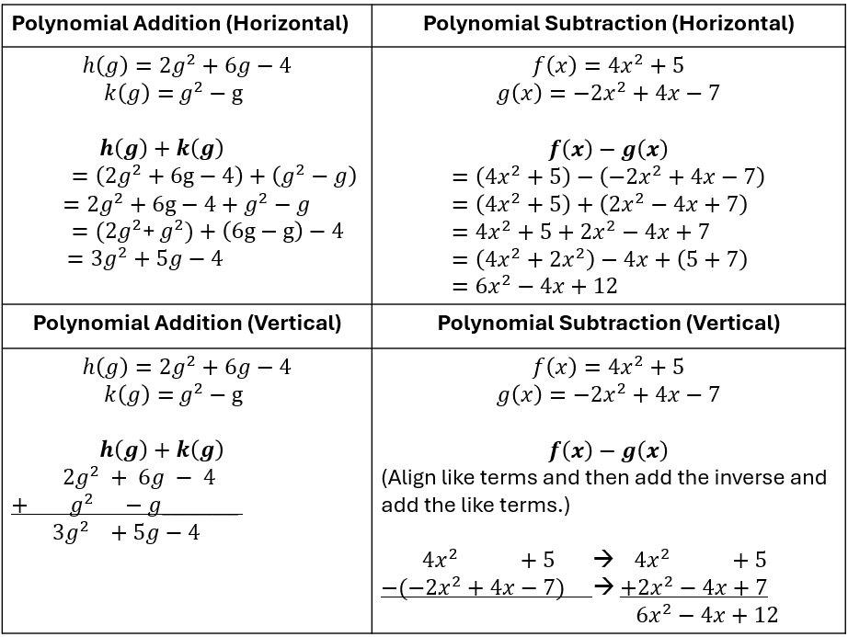

* There are several methods that can be used to multiply polynomials, including the use of the distributive property, pictorial models, or graphic organizers. Examples of methods for polynomial multiplication are shown below.

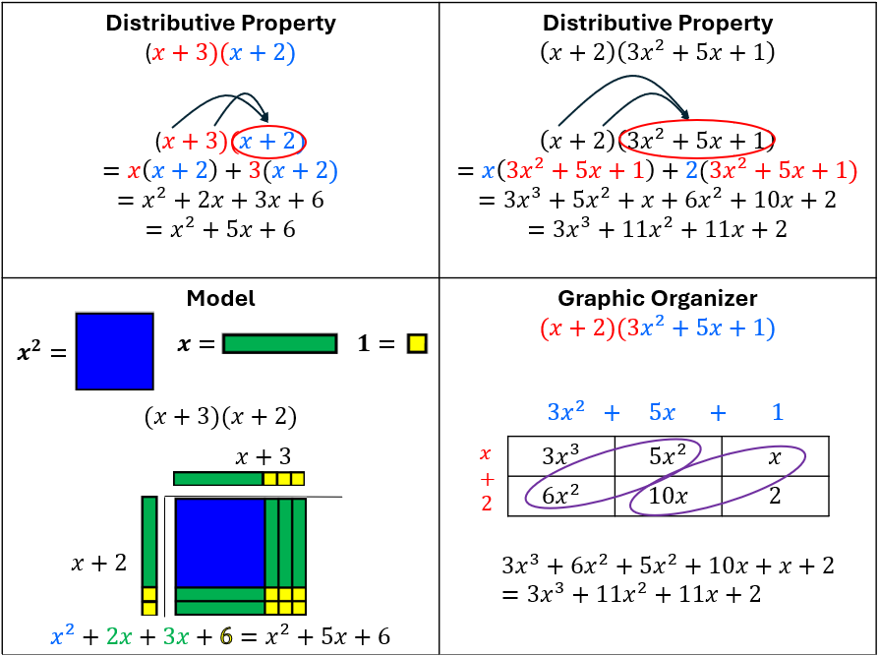

* In Algebra 2, students are expected to divide polynomials with divisors that are monomials, binomials, or factorable trinomials. Examples are shown in the table below.

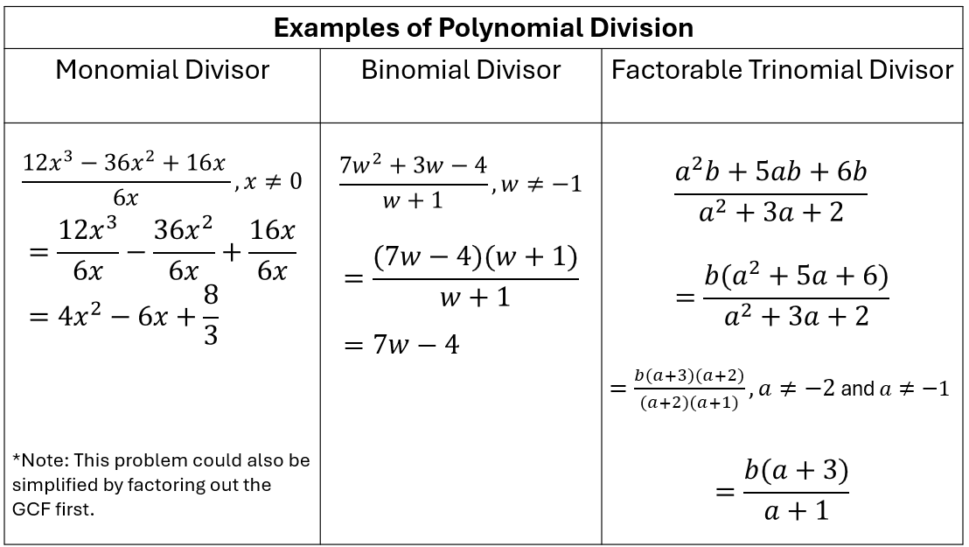

* Applying laws of exponents is required when multiplying or dividing polynomial expressions.
* The rules of exponents include:
  + Negative Exponent Rule: $a^{-n}=\frac{1}{a^{n}}, a≠0 ($ For any nonzero number $a$ and positive integer $n$, a negative exponent means the reciprocal of the base raised to the positive exponent.)
    - Example: $4^{-2}=\frac{1}{4^{2}}=\frac{1}{16}$
    - Example: $\frac{x^{4}}{y^{-2}}, y≠0$
 $$=\frac{x^{4}}{\frac{1}{y^{2}}}=\frac{x^{4}}{1}∙\frac{y^{2}}{1}=x^{4}y^{2}$$

 + Zero Exponent Rule: $a^{0}=1, a≠0$ (For any nonzero number $a$, raising it to the power of 0 always equals 1.)
    - Example: ${(-5)}^{0}=1$
    - Example: ${\left(6xy\right)}^{0}=1$
    - Example: ${4m}^{0}=4∙1=4$
    - Example: ${\left(\frac{2}{3}\right)}^{0}=1$
  + Product of Powers Property: When multiplying two exponential expressions with the same base, add the exponents.
    - Example: $a^{m}$ $∙$ $a^{n}$ = $a^{m+n}$
    - Example: $a^{2}∙a^{5}=\left(a∙a\right)\left(a∙a∙a∙a∙a\right)=a∙a∙a∙a∙a∙a∙a=a^{7}$
    - Example: $x^{3}∙x=x^{4}$
    - Example: $w^{\frac{1}{3}}∙w^{\frac{1}{4}}=w^{\frac{1}{3}+\frac{1}{4}}=w^{\frac{7}{12}}$
  + Power of a Power Property: When raising a power to another power, multiply the exponents.
    - Example: ${{(a}^{m})}^{n}=a^{m∙n}$
    - Example: ${{(a}^{2})}^{4}={(a}^{2}){(a}^{2}){(a}^{2}){(a}^{2})=\left(a∙a\right)\left(a∙a\right)\left(a∙a\right)\left(a∙a\right)=a∙a∙a∙a∙a∙a∙a∙a=a^{8}$
    - Example: ${(g^{2})}^{-3}=g^{2∙(-3)}=g^{-6}=\frac{1}{g^{6}}, g≠0$
    - Example: ${\left(y^{\frac{1}{4}}\right)}^{8}=y^{(\frac{1}{4}∙\frac{8}{1})}=y^{2}$
  + Power of a Product Property: When raising a product to a power, apply the exponent to each factor individually.
    - Example: ${(ab)}^{m}=a^{m}∙b^{m}$
    - Example: ${(3x)}^{2}=3^{2}∙x^{2}={9x}^{2}$
    - Example: ${(-3a^{4}b)}^{2}={(-3)}^{2}∙{{(a}^{4})}^{2}∙b^{2}=9a^{8}b^{2}$
    - Example: ${(9a^{4}b^{6})}^{\frac{1}{2}}={\left(9\right)}^{\frac{1}{2}}∙{\left(a^{4}\right)}^{\frac{1}{2}}∙{\left(b^{6}\right)}^{\frac{1}{2}}=3a^{2}b^{3}$
  + Quotient of Powers Property: When dividing two exponential expressions with the same base, subtract the exponents.
    - Example: $\frac{a^{m}}{a^{n}}=a^{m-n}, a≠0$
    - Example: $\frac{a^{5}}{a^{2}}, a≠0$
 $$=\frac{a∙a∙a∙a∙a}{a∙a}=\frac{a∙a∙a}{1}∙\frac{a∙a}{a∙a}=\frac{a^{3}}{1}∙1=a^{3}$$

   - Example: $\frac{x^{6}}{x^{5}}, x≠0$
 $$=x^{6-5}=x^{1}=x$$

   - Example: $\frac{n^{-3}}{n^{-5}}=n^{-3-(-5)}=n^{2}$
    - Example: $\frac{b^{4}}{b^{4}}, b≠0$
 $$=b^{4-4}=b^{0}=1$$

   - Example: $\frac{x^{\frac{3}{5}}}{x^{\frac{1}{5}}}=x^{\frac{3}{5}-\frac{1}{5}}=x^{\frac{2}{5}}$
  + Power of Quotient Property: When raising a fraction to a power, apply the exponent to both the numerator and denominator separately.
    - Example: ${\left(\frac{a}{b}\right)}^{m}=\frac{a^{m}}{b^{m}}, b≠0$
    - Example: ${\left(\frac{y}{3}\right)}^{4}=\frac{y^{4}}{3^{4}}=\frac{y^{4}}{81}$
    - Example: ${\left(\frac{5}{t}\right)}^{-3}, t≠0$
$$=\frac{5^{-3}}{t^{-3}}=\frac{\frac{1}{5^{3}}}{\frac{1}{t^{3}}}=\frac{1}{5^{3}}∙\frac{t^{3}}{1}=\frac{t^{3}}{5^{3}}=\frac{t^{3}}{125}$$

* Factoring polynomials completely assists with dividing and simplifying polynomial expressions.
* The complete factorization of polynomials occurs when each factor cannot be written as the product of polynomials of lower degree.
* When a polynomial cannot be factored into a product of lesser degree polynomial factors, the polynomial is called a *prime polynomial*. Examples of prime polynomials include $r, 3t+9, x^{2}+1, 5y^{2}-4y+3$.
* Polynomials may be factored using various methods, including but not limited to, grouping or recognizing general patterns such as difference of squares, sum and difference of cubes, and perfect square trinomials.
  + Greatest common factor (GCF): find the greatest common factor of all terms of the polynomial and then apply the distributive property
    - Example: $20a^{4}+8=4a(5a^{3}+2)$
  + Grouping (for trinomials of the form ${ax}^{2}+bx+c$)
    - Example: ${3x}^{2}+8x+4$

$={3x}^{2}+2x+6x+4$ [Rewrite 8x as $2x+6x]$

$=\left({3x}^{2}+2x\right)+\left(6x+4\right)$ [Group factors]

$=x\left(3x+2\right)+2\left(3x+2\right)$ [Factor out a common binomial]

* + Difference of squares: $a^{2}-b^{2}=(a+b)(a-b)$
    - Example: $n^{2}-49=n^{2}-7^{2}=(n+7)(n-7)$
    - Example: $4-x^{2}=2^{2}-x^{2}=(2-x)(2+x)$
    - Example: ${9x}^{2}-{25y}^{2}={\left(3x\right)}^{2}-{\left(5y\right)}^{2}=(3x+5y)(3x-5y)$
  + Sum of cubes: $a^{3}+b^{3}=(a+b)(a^{2}-ab+b^{2})$
    - Example: ${27y}^{3}+1={(3y)}^{3}+1^{3}=(3y+1)({9y}^{2}-3y+1)$
    - Example: ${125a}^{3}+64b^{3}={\left(5a\right)}^{3}+{\left(4b\right)}^{3}=(5a+4b)(25a^{2}-20ab+16b)$
  + Difference of cubes: $a^{3}-b^{3}=(a-b)(a^{2}+ab+b^{2})$
    - Example: $8-b^{3}=2^{3}-b^{3}=(2-b)(4+2b+b^{2})$
    - Example: ${64x}^{3}-{27y}^{3}={\left(4x\right)}^{3}-{\left(3y\right)}^{3}=(4x-3y)({16x}^{2}+12xy+{9y}^{2})$
  + Perfect square trinomials: $a^{2}+2ab+b^{2}={\left(a+b\right)}^{2}$ or $a^{2}-2ab+b^{2}={\left(a-b\right)}^{2}$
    - Example: $x^{2}+6x+9^{2}=x^{2}+2(3)(x)+3^{2}={\left(x+3\right)}^{2}$
    - Example: ${4n}^{2}-20n+25={\left(2n\right)}^{2}-2(2n)(5)+5^{2}={\left(2n-5\right)}^{2}$
    - Example: ${9a}^{2}+12ab+{4b}^{2}={(3a)}^{2}+2(3a)(2b)+{(2b)}^{2}={\left(3a+2b\right)}^{2}$
* Techniques for factoring quadratic expressions can be extended to factoring some higher degree binomials and trinomials. For example, $x^{4}+2x^{2}-8$ can be expressed in an equivalent form as $\left(x^{2}+4\right)\left(x^{2}-2\right)$.
* For division of polynomials in this standard, students may benefit from experiences with multiple methods, to include, but not limited to long or synthetic division.
* Polynomial expressions can be used to define functions, and these functions can be represented graphically.
* Rewriting a polynomial expression in different but equivalent forms allows some aspects of the expression to become more apparent. For example, a quadratic expression written in vertex form allows the vertex to be found by visual inspection of the expression. The quadratic written in standard form allows for the $y$-intercept to be found by visual inspection.
  + Vertex form: $y=a({x-h)}^{2}+k$, where $(h, k)$ is the vertex.
  + Standard form: $y=ax^{2}+bx+c$, with $y$*-*intercept at $(0, c)$.

###### Skills in Practice

While the five process goals are expected to be embedded in each standard, the Skills in Practice highlight the most prevalent process goals in relation to the content presented.

**Mathematical Problem Solving:** Students should be presented with many opportunities to factor polynomial expressions with one and two variables in a variety of ways. As students become more comfortable with factoring polynomial expressions, they should become proficient with being able to recognize patterns of common factoring methods and use them accurately, as appropriate.

* When factoring a polynomial expression, students should be encouraged to first factor out the greatest common factor (GCF) from each term. While it is not necessary to factor out the great common factor first, not doing so can lead to students having to perform more cumbersome calculations. Therefore, teachers should encourage students to factor out the GCF, which will result in a simpler polynomial expression to factor. Consider the expression, ${36x}^{2}-6xy-{20y}^{2}$. Students should recognize that each term has a factor of 2, which can be factored out, resulting in ${2(18x}^{2}-3xy-{10y}^{2}).$
* When factoring polynomial expressions, students should determine the complete factorization of the polynomial. Consider the expression $x^{4}-12x+32$. A common error is for students to only factor this expression into the product of two binomials, ($x^{2}-8)(x^{2}-4)$. This may indicate that students incorrectly believe that factoring an expression can only result in two factors. Teachers may want to provide opportunities where students must select all the factors to help students understand that expressions can have more than two factors. Additionally, this error may result from students not recognizing that ${(x}^{2}-4)$ can be factored further. A variety of experiences factoring different types of polynomials will help students strengthen their understanding of common factoring methods and patterns.

**Mathematical Connections:** Students should have opportunities to factor polynomial expressions that represent polynomial identities such as difference of squares, sum and difference of cubes, and perfect square trinomials. Consider the example below.

Factor the expression completely.

$$8x^{6}-125y^{3}$$

Students should be able to make the connection between this expression and the factoring of two perfect cubes, $a^{3}-b^{3}=\left(a-b\right)\left(a^{2}+ab+b^{2}\right).$ A common error students may make when factoring the difference of two perfect cubes with higher degree terms is to not completely square the $a$ or $b$ term, resulting in $(2x^{2}-5y)(4x^{2}+10x^{2}y+25y)$, which is not equivalent to the original expression. This error may indicate that the students squared the coefficient but neglected to square the variable components of $a$ and $b$. The teacher may want to spend time reviewing the laws of exponents. Another strategy is to have students multiply their factors to verify the product is equivalent to the original expression.

###### Concepts and Connections

Concepts

Expressions can be used to describe and define real-life contextual situations. Simplifying polynomial expressions through sums, differences, products, quotients, and factoring, allows us to make sense of algebraic data in comparable ways that we understand numerical data.

Connections

* *Within the grade level/course*:
  + A2.EO.1 – The student will perform operations on and simplify rational expressions.
  + A2.EO.2 – The student will perform operations on and simplify radical expressions.
  + A2.EO.4 – The student will perform operations on complex numbers.
* *Vertical Progression*:
  + A.EO.1 – The student will represent verbal quantitative situations algebraically and evaluate these expressions for given replacement values of the variables.
  + A.EO.2 – The student will perform operations on and factor polynomial expressions in one variable.
  + A.EO.3 – The student will derive and apply the laws of exponents.
  + A.EO.4 – The student will simplify and determine equivalent radical expressions involving square roots of whole numbers and cube roots of integers.

###### Resources to Support Local Curriculum

* A list of approved textbooks and instructional materials is posted on the VDOE [website](https://www.doe.virginia.gov/teaching-learning-assessment/k-12-standards-instruction/mathematics/2024-mathematics-textbooks).
* [EOC Algebra 2 Formula Sheet](https://www.doe.virginia.gov/home/showpublisheddocument/56035/638581953490870000)(PDF)
* [Table of Standard Normal Probabilities](https://www.doe.virginia.gov/home/showpublisheddocument/20152/638043600831870000) (*z*-table) (PDF)

### A2.EO.4

##### The student will perform operations on complex numbers.

1. Students will demonstrate the following Knowledge and Skills:
2. Explain the meaning of *i*.
3. Identify equivalent radical expressions containing negative rational numbers and expressions in *a* + *bi* form.
4. Apply properties to add, subtract, and multiply complex numbers.

###### Understanding the Standard

* $i$ is the imaginary unit that satisfies the equation $i^{2}=-1$, where $i=\sqrt{-1}.$
* $i$ can be described using a cyclical approach:
$i= \sqrt{-1}$

$i^{2}=-1$

$i^{3}=-i$

$i^{4}=1$

$i^{5}= \sqrt{-1}$

* All complex numbers can be written in the form $a+bi$, where $a$ and $b$ are real numbers.
  + $a$ is the real part of the complex number
  + $bi$ is the imaginary part of the complex number
  + Either $a$ or $b$ can be equal to 0
    - Examples where $a=0$ include $-i, 0.01i, \frac{2i}{5}$
    - Examples where $b=0$ include $\sqrt{5}, 4, -12.8$
    - Examples where $a≠0$ and $b≠0$ include $39-6i, -2+πi, \frac{1}{4}+3i$
* A complex number consists of both real (*a*) and imaginary (*bi*) parts but either part can be 0, resulting in a real number or a pure imaginary number, which are both subsets of the complex number system. For example:
  + $5+0i=5$ (real number)
  + $±\sqrt{-9}=0±3i=±3i$ (pure imaginary numbers)
* Radical expressions containing negative rational numbers and expressions can be represented in *a* + *bi* form. For example, $\sqrt{-\frac{4}{25}}+2$ is equivalent to $2+\frac{2}{5}i$.
* Complex numbers can be added, subtracted, multiplied, or divided. In Algebra 2, students are expected to add, subtract, and multiply complex numbers. Algebraic properties apply to complex numbers as well as real numbers. Examples of computation with complex numbers are shown below.

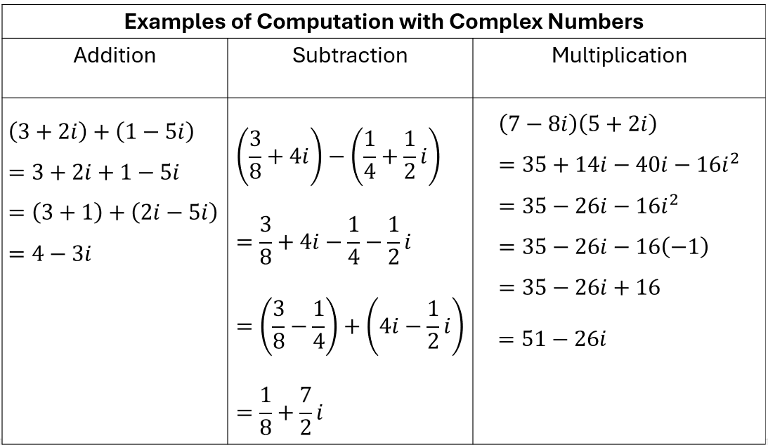

###### Skills in Practice

While the five process goals are expected to be embedded in each standard, the Skills in Practice highlight the most prevalent process goals in relation to the content presented.

**Mathematical Reasoning:** As students develop their understanding of complex numbers, they may not have a strong understanding of what $i$ means and may simplify expressions incorrectly. For example, if given the expression $7+\sqrt{-81}$, students may simplify the radical to $-9$ instead of $9i$. This may indicate that the student does not recognize that the square root of a negative number is an imaginary number. Having students rewrite the problem as $7+\sqrt{-1}∙\sqrt{81}$ can help students identify the imaginary portion of the square root.

* **Mathematical Connections:** As students engage in multiplication of complex numbers, they should have experience multiplying a complex number by its conjugate. The conjugate of a complex number $a+bi$ is $a-bi$. When a complex number is multiplied by its conjugate, the result is equal to a non-negative real number. Consider the example below.

$$\left(3+4i\right)\left(3-4i\right)$$

$$=9-12i+12i-16i^{2}$$

$$=9-16i^{2}$$

$$=9-16\left(-1\right)$$

$$=9+16$$

$$=25$$

###### Concepts and Connections

Concepts

Complex numbers include imaginary units that cannot be defined in a real number system.

Connections

* *Within the grade level/course*:
  + A2.EO.1 – The student will perform operations on and simplify rational expressions.
  + A2.EO.2 – The student will perform operations on and simplify radical expressions.
  + A2.EO.3 – The student will perform operations on polynomial expressions and factor polynomial expressions in one and two variables.
* *Vertical Progression*:
  + A.EO.1 – The student will represent verbal quantitative situations algebraically and evaluate these expressions for given replacement values of the variables.
  + A.EO.2 – The student will perform operations on and factor polynomial expressions in one variable.
  + A.EO.3 – The student will derive and apply the laws of exponents.
  + A.EO.4 – The student will simplify and determine equivalent radical expressions involving square roots of whole numbers and cube roots of integers.

###### Resources to Support Local Curriculum

* A list of approved textbooks and instructional materials is posted on the VDOE [website](https://www.doe.virginia.gov/teaching-learning-assessment/k-12-standards-instruction/mathematics/2024-mathematics-textbooks).
* [EOC Algebra 2 Formula Sheet](https://www.doe.virginia.gov/home/showpublisheddocument/56035/638581953490870000)(PDF)
* [Table of Standard Normal Probabilities](https://www.doe.virginia.gov/home/showpublisheddocument/20152/638043600831870000) (*z*-table) (PDF)

## Equations and Inequalities

Equations and inequalities are major components of algebra. Equations and inequalities are comprised of expressions and operations. These skills lead to the understanding and analysis of functions. Also, mastery of solving equations and inequalities is essential for developing and creating mathematical models. Knowledge of equations and inequalities is required for all mathematics courses, beyond Algebra 2.

Throughout Algebra 2, students will represent, solve, and interpret the solution to absolute value, quadratic, rational, and radical equations, and absolute value inequalities in one variable. Students will apply skills learned about systems of two linear equations to solve systems containing a quadratic expression. Additionally, students will solve and interpret the solution to a polynomial equation.

### A2.EI.1

##### The student will represent, solve, and interpret the solution to absolute value equations and inequalities in one variable.

1. Students will demonstrate the following Knowledge and Skills:
2. Create an absolute value equation in one variable to model a contextual situation.
3. Solve an absolute value equation in one variable algebraically and verify the solution graphically.
4. Create an absolute value inequality in one variable to model a contextual situation.
5. Solve an absolute value inequality in one variable and represent the solution set using set notation, interval notation, and using a number line.
6. Verify possible solution(s) to absolute value equations and inequalities in one variable algebraically, graphically, and with technology to justify the reasonableness of answer(s). Explain the solution method and interpret solutions for problems given in context.

###### Understanding the Standard

* The definition of absolute value (for any real numbers *a* and *b*, where *b* > 0, if |*a*|= *b*, then *a* = *b* or *a* = − *b*) is used in solving absolute value equations and inequalities.
* The absolute value of any number is the distance from that number to zero on a number line.
* Absolute value equations and inequalities in one variable can be solved algebraically using a compound statement. For example, the solution set for $\left|2x-3\right|=x+1$ can be found by solving $2x-3=x+1$ and $2x-3=-\left(x+1\right)$. It is important to properly distribute the negative to all terms in the second equation.
* Compound statements representing solutions of an inequality in one variable can be represented graphically on a number line.
* Practical problems can be interpreted, represented, and solved using equations and inequalities.
* Solutions and intervals may be expressed in different formats, including equations and inequalities, set notation, or interval notation.
  + Set notation is used when explicitly identifying each element of the solution set. It is represented using braces around the solution set.
  + Interval notation is used when describing a range of values. It can be used to define solutions to inequalities. A bracket is used when the endpoint of the range is included (i.e., ). A parenthesis is used when the endpoint of the range is not included (i.e., ). Additionally, a parenthesis is always used with infinity and negative infinity (∞ and -∞, respectively).
* Examples may include:

|  |  |  |
| --- | --- | --- |
| **Equation/Inequality** | **Set Notation** | **Interval Notation** |
| $$x = 3$$ | $$\{3\}$$ |  |
| $x = 3$ or |  |  |
|  |  |  |
|  | {} |  |
| Empty (null) set ∅ | { } |  |

* The process of solving equations or inequalities can lead to extraneous solutions.
* An extraneous solution is a solution of the simplified form of an equation/inequality that does not satisfy the original equation/inequality. The use of substitution can be used to verify solutions. For example, consider the equation $\left|x-4\right|=2x+1$. Solving this equation results in two solutions, $x=-5$ or $x=1$. However, when substituting $x=-5$ into the original equation, the result is $\left|-9\right|=-9$, which is not possible. Thus, $x=-5$ is an extraneous solution.
* Properties of Real Numbers and Properties of Equality/Inequality are applied to solve equations/inequalities.
* Properties of Real Numbers:
* Associative Property of Addition: $\left(a+b\right)+c=a+(b+c)$
* Associative Property of Multiplication: $\left(a∙b\right)∙c=a∙(b∙c)$
* Commutative Property of Addition: $a+b=b+a$
* Commutative Property of Multiplication: $a∙b=b∙a$
* Identity Property of Addition (Additive Identity): $a+0=a$
* Identity Property of Multiplication (Multiplicative Identity): $a∙1=a$
* Inverse Property of Addition (Additive Inverse): $a+\left(-a\right)=0$
* Inverse Property of Multiplication (Multiplicative Inverse): $a∙\frac{1}{a}=1,$ for $a≠0$
* Distributive Property: $a\left(b+c\right)=ab+bc$ or $a\left(b-c\right)=ab-ac$
* Properties of Equality:
* Multiplicative Property of Zero: $a∙0=0$
* Zero Product Property: If $ab=0$, then $a=0$ or $b=0$.
* Reflexive Property: $a=a$
* Symmetric Property: If $a=b$, then $b=a$.
* Transitive Property of Equality: If $a=b$ and $b=c$, then $a=c$.
* Addition Property of Equality: If $a=b,$ then $a+c=b+c$.
* Subtraction Property of Equality: If $a=b$, then $a-c=b-c$.
* Multiplication Property of Equality: If $a=b$, then $a∙c=b∙c$.
* Division Property of Equality: If $a=b,$ then $\frac{a}{c}=\frac{b}{c}, c≠0$.
* Substitution Property of Equality: If $a=b$, then $a$ can replace $b$ in any expression.
* Properties of Inequality:
* Transitive Property of Inequality
  + If $a<b$ and $b<c$, then $a<c$.
  + If $a>b$ and $b>c$, then $a>c$.
* Addition Property of Inequality
  + If $a<b$, then $a+c<b+c$.
  + If $a>b$, then $a+c>b+c$.
* Subtraction Property of Inequality
  + If $a<b$, then $a-c<b-c$.
  + If $a>b$, then $a-c>b-c$.
* Multiplication Property of Inequality
  + If $c>0$ and $a<b$, then $a∙c<b∙c$.
  + If $c>0$ and $a>b$, then $a∙c>b∙c$.
  + If $c<0$ and $a<b,$ then $a∙c>b∙c$.
  + If $c<0$ and $a>b$, then $a∙c<b∙c$.
* Division Property of Inequality
  + If $c>0$ and $a<b$, then $\frac{a}{c}<\frac{b}{c}$.
  + If $c>0$ and $a>b$, then $\frac{a}{c}>\frac{b}{c}$.
  + If $c<0$ and $a<b$, then $\frac{a}{c}>\frac{b}{c}$.
  + If $c<0$ and $a>b$, then $\frac{a}{c}<\frac{b}{c}$.
* Substitution Property of Inequality
  + If $a=b$ and $c<a$, then $c<b$.
  + If $a=b$ and $c>a$, then $c>b$.

###### Skills in Practice

While the five process goals are expected to be embedded in each standard, the Skills in Practice highlight the most prevalent process goals in relation to the content presented.

**Mathematical Problem Solving:** As students gain experience with absolute value equations and inequalities, quadratic equations and inequalities, systems of equations containing a quadratic expression, and equations containing rational algebraic expressions, they may have difficulty distinguishing between the types of equations and inequalities. In addition, they may struggle to determine when each type applies to a contextual situation and may have difficulty creating equations and inequalities to match contextual situations.

As students deepen their understanding of absolute value equations and inequalities, they may have difficulty creating an absolute value equation in one variable to model a contextual situation. Consider the following scenario.

A sports company wants every basketball it makes to have a diameter of exactly 24 centimeters. During a set of quality checks, one basketball was found to have a diameter that was .75 centimeters off from the standard size. What could be the diameter of the basketball?

First, students may have difficulty determining whether this scenario is best represented by an absolute value equation or inequality. Once they determine that it is best represented by an absolute value equation, students may struggle to create the equation. For example, they may incorrectly determine that $\left|x-0.75\right|=24$, rather than $\left|x-24\right|=0.75.$ Helping students understand what each part of an absolute value equation represents will benefit students as they create absolute value equations. For example, in an absolute value equation of the form $\left|x-a\right|=b$, the $x$ is the value they’re solving for, $a$ is the expected value, and $b$ is the difference from the expected value to the actual value. In addition, facilitating classroom discussions about contextual problems can help students understand what is happening in the problem.

**Mathematical Representations:** Students can represent absolute value equations and inequalities graphically or using number lines. Similarly, students can solve absolute value equations and inequalities algebraically and then verify their solutions graphically.

* Consider the absolute value equation, $\left|5x-2\right|=3x+5$. When solving, it is important that students understand how to properly distribute the negative for the second equation, resulting in $5x-2=3x+5$ and $5x-2=-3x-5$. This leads to solutions of $x=-\frac{3}{8}$ and $x=\frac{7}{2}.$ Students should have an opportunity to graph the related functions, $y=|5x-2|$ and $y=3x-5$, and determine where the two functions intersect to verify the solutions of the absolute value equation graphically. (Note: While absolute value functions are not specifically addressed in the Algebra 2 standards, the related functions should be addressed when solving absolute value equations and inequalities.)
* Students should have opportunities to verify their solutions graphically to determine the points of intersection, as modeled below.

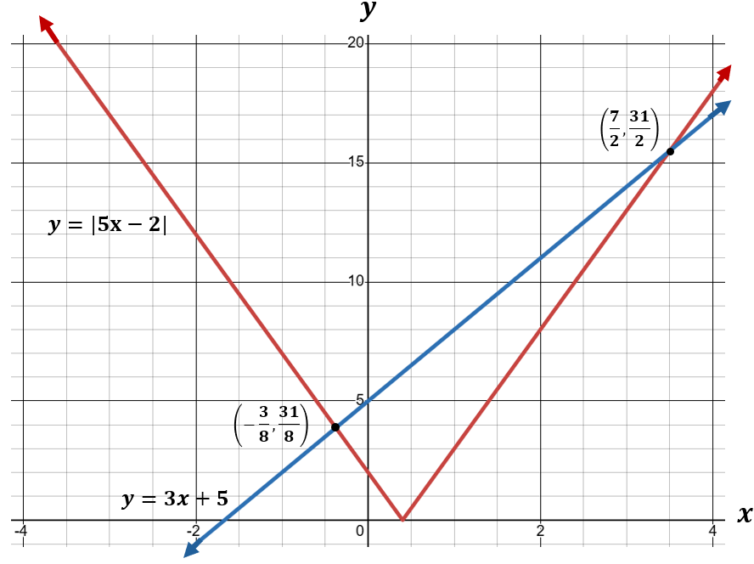

* Students should have experience solving absolute value inequalities and representing the solution set using a number line. Several examples are shown below.

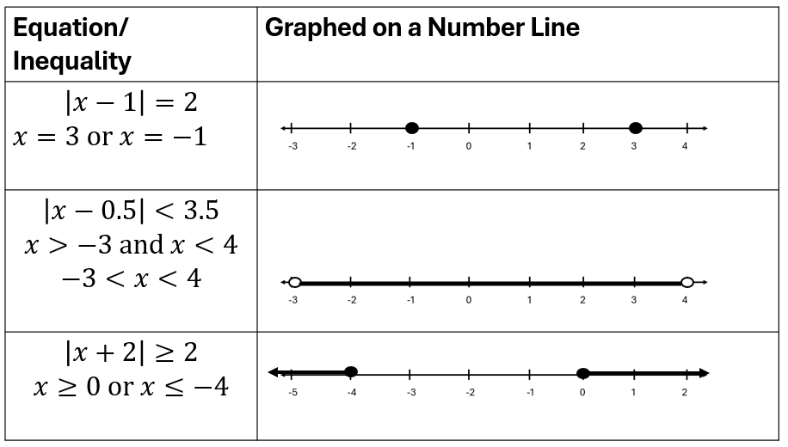

###### Concepts and Connections

Concepts

Absolute value equations and inequalities can be used to model real-life contextual situations.

Connections

* *Within the grade level/course:*
  + A2.EI.2 – The student will represent, solve, and interpret the solution to quadratic equations in one variable over the set of complex numbers and solve quadratic inequalities in one variable.
  + A2.EI.3 – The student will solve a system of equations in two variables containing a quadratic expression.
  + A2.EI.4 – The student will represent, solve, and interpret the solution to an equation containing rational algebraic expressions.
  + A2.EI.5 – The student will represent, solve, and interpret the solution to an equation containing a radical expression.
  + A2.EI.6 – The student will represent, solve, and interpret the solution to a polynomial equation.
* *Vertical Progression*:
  + A.EI.1 – The student will represent, solve, explain, and interpret the solution to multistep linear equations and inequalities in one variable and literal equations for a specified variable.
  + A.EI.2 – The student will represent, solve, explain, and interpret the solution to a system of two linear equations, a linear inequality in two variables, or a system of two linear inequalities in two variables.
  + A.EI.3 – The student will represent, solve, and interpret the solution to a quadratic equation in one variable.

###### Resources to Support Local Curriculum

* A list of approved textbooks and instructional materials is posted on the VDOE [website](https://www.doe.virginia.gov/teaching-learning-assessment/k-12-standards-instruction/mathematics/2024-mathematics-textbooks).
* [EOC Algebra 2 Formula Sheet](https://www.doe.virginia.gov/home/showpublisheddocument/56035/638581953490870000)(PDF)
* [Table of Standard Normal Probabilities](https://www.doe.virginia.gov/home/showpublisheddocument/20152/638043600831870000) (*z*-table) (PDF)

### A2.EI.2

##### The student will represent, solve, and interpret the solution to quadratic equations in one variable over the set of complex numbers and solve quadratic inequalities in one variable.

1. Students will demonstrate the following Knowledge and Skills:
2. Create a quadratic equation or inequality in one variable to model a contextual situation.
3. Solve a quadratic equation in one variable over the set of complex numbers algebraically.
4. Determine the solution to a quadratic inequality in one variable over the set of real numbers algebraically.
5. Verify possible solution(s) to quadratic equations or inequalities in one variable algebraically, graphically, and with technology to justify the reasonableness of answer(s). Explain the solution method and interpret solutions for problems given in context.

###### Understanding the Standard

* Quadratic equations and inequalities can be used to represent, interpret, and solve contextual problems.
* Quadratic equations can be solved in a variety of ways, including graphing, factoring, the quadratic formula, and completing the square.
* The quadratic formula and completing the square can be used to solve any quadratic equation over the set of complex numbers.
* The quadratic formula shows that the solutions to the equation $ax^{2}+bx+c=0$ are $x=\frac{-b±\sqrt{b^{2}-4ac}}{2a}$.
* The discriminant of the equation $ax^{2}+bx+c=0$ is defined as $b^{2}-4ac$.
* The value of the discriminant of a quadratic equation can be used to describe the number and type of solutions to the equation:
  + If $b^{2}-4ac>0,$ then the equation has two real solutions. Further, if the discriminant is a rational number, then the original equation could be solved by factoring.
  + If $b^{2}-4ac=0$, then the equation has one real solution with a multiplicity of 2.
  + If $b^{2}-4ac<0$, then the equation has two complex, non-real, solutions.

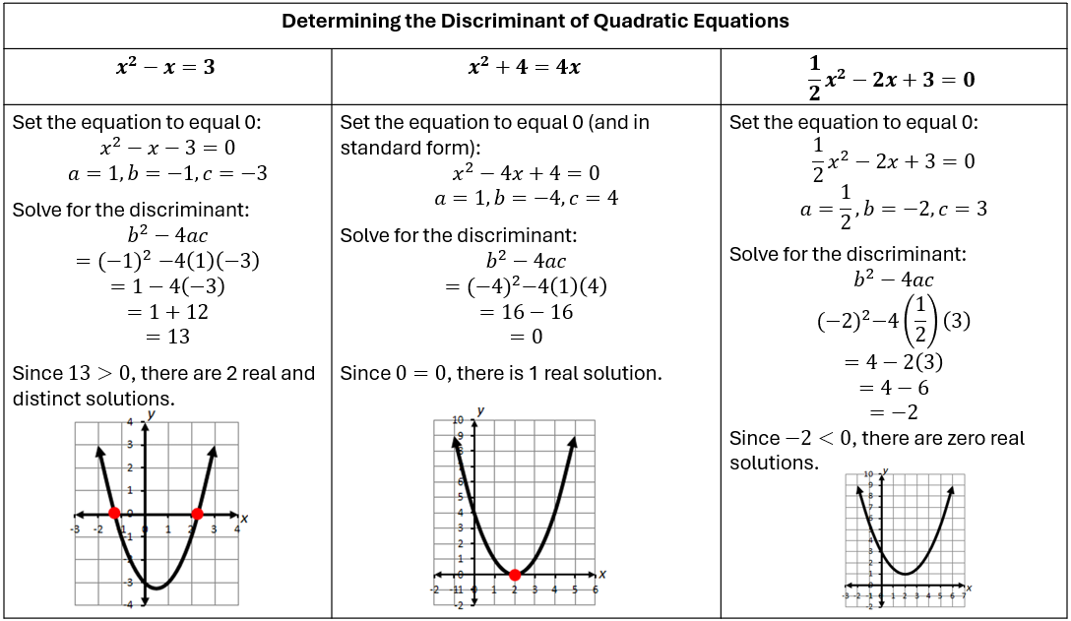

* The quadratic formula can be derived by applying the completion of squares to the standard form of a quadratic equation.
* Solutions of quadratic equations are real or a sum or difference of a real and imaginary component.
* Complex solutions occur in conjugate pairs. The conjugate of a complex number, $a+bi$, is equivalent to $a-bi$.
* Quadratic equations with exactly one real root can be referred to as having one distinct root with a multiplicity of two. This is called a double root. For instance, the quadratic equation, $x^{2}-4x+4$, has two identical factors $\left((x-2\right)\left(x-2\right))$, giving one real root with a multiplicity of two. In this case, the equation is a perfect square trinomial.
* Solutions and intervals may be expressed in different formats, including equations and inequalities, set notation, or interval notation.
  + Set notation is used when explicitly identifying each element of the solution set. It is represented using braces around the solution set.
  + Interval notation is used when describing a range of values. It can be used to define solutions to inequalities. A bracket is used when the endpoint of the range is included (i.e., ). A parenthesis is used when the endpoint of the range is not included (i.e., ). Additionally, a parenthesis is always used with infinity and negative infinity (∞ and -∞, respectively).
* Examples may include:

|  |  |  |
| --- | --- | --- |
| **Equation/Inequality** | **Set Notation** | **Interval Notation** |
| $$x = 3$$ | $$\{3\}$$ |  |
| $x = 3$ or |  |  |
|  |  |  |
|  | {} |  |
| Empty (null) set ∅ | { } |  |

* Sign charts can be used to solve quadratic inequalities.

Consider the example: $x^{2}+3x+2≥0$ $(x+2)(x+1)≥0$

Equality holds when $x=-2$ and $x=-1$

Create a sign chart to analyze the intervals that make up the solution set of the inequality:

|  |  |  |  |
| --- | --- | --- | --- |
| Interval | $$x<-2$$ | $$-2<x<-1$$ | $$x>-1$$ |
| Test Value | $$-3$$ | $$-1.5$$ | $$0$$ |
| Sign Analysis | $$\left(-\right)\left(-\right)=+$$ | $$\left(+\right)\left(-\right)=-$$ | $$\left(+\right)\left(+\right)=+$$ |

The solution is $x≤-2$ and $x≥-1$.

###### Skills in Practice

While the five process goals are expected to be embedded in each standard, the Skills in Practice highlight the most prevalent process goals in relation to the content presented.

**Mathematical Problem Solving:** As students gain experience with absolute value equations and inequalities, quadratic equations and inequalities, systems of equations containing a quadratic expression, and equations containing rational algebraic expressions, they may have difficulty distinguishing between the types of equations and inequalities. In addition, they may struggle to determine when each type applies to a contextual situation and may have difficulty creating equations and inequalities to match contextual situations.

As students deepen their understanding of quadratic equations and inequalities, they may have difficulty creating a quadratic equation in one variable to model a contextual situation. Consider the following scenario.

A family is building a rectangular garden next to their house, and they want to enclose the garden with a fence. The house will form one side of the rectangle, so they only need fencing on three sides. They have 36 meters of fencing to use, and they want the area of the garden to be 120 square meters. What should be the dimensions of the garden?

Students may understand that this problem addresses area and recognize that they must use the formula $length ∙width=Area$. However, they may be unsure how to determine expressions to represent the length and width. In the example above, let $x$ represent the width. Then the length is equal to $36-2x$, and the area can be determined by $x\left(36-2x\right)=120.$ Facilitating classroom discussions about contextual problems and hearing other solution methods can help students understand what is happening in the problem.

**Mathematical Reasoning:** As students develop their understanding of quadratic equations and inequalities, they should be exposed to quadratic equations and inequalities written multiple ways. Some common errors that arise as students work with quadratics are discussed below.

* When solving quadratic equations algebraically using the quadratic formula, students should be encouraged to set the quadratic equation equal to zero prior to identifying the values of *a*, *b*, and *c*. Consider the following equation: $2x^{2}-3x=4$. A common mistake students make is to substitute values into the quadratic formula without having set the equation equal to zero first (e.g., $c=4,$ rather than $c=-4$). This may indicate that students have not connected the solutions to the zeros of an equation. Reinforcing this vocabulary could help students realize that to find the zeros (solutions), the equation must be set equal to zero first. A similar mistake can occur when the equation is not written in standard form. Consider the equation ${3x}^{2}-8+4x=0$. Students may incorrectly state that $b=-8$ and $c=4$. This indicates that students determined the values of *a, b,* and *c* by the order they were written, rather than through the correct use of the formula. Students should be encouraged to write the equation in standard form, $ax^{2}+bx+c=0$ prior to determining the values for *a, b,* and *c.*
* When solving quadratic equations algebraically using the quadratic formula, values of *a, b,* and *c* may not be integers. Consider the equation: $\frac{1}{2}x^{2}-\frac{1}{4}x-2=0$. Students may make errors substituting rational values for *a*, *b*, and *c* when using the quadratic formula. This may indicate that students lack proficiency with operations with rational numbers. Teachers should encourage students to write an equivalent equation by multiplying all the terms of the equation by a scalar value that will produce integer coefficients before using the quadratic formula. In the example above, the equation could be multiplied by 4 to create an equivalent equation, ${2x}^{2}-x-8=0$. Care must be taken to multiply each term of the equation by the selected scalar when creating an equivalent equation. Students can verify the real solutions to a quadratic equation by graphing the related function and finding the zeros.

###### Concepts and Connections

Concepts

Quadratic equations can be used to model real-life contextual situations.

Connections

* *Within the grade level/course:*
  + A2.EI.1 – The student will represent, solve, and interpret the solution to absolute value equations and inequalities in one variable.
  + A2.EI.3 – The student will solve a system of equations in two variables containing a quadratic expression.
  + A2.EI.4 – The student will represent, solve, and interpret the solution to an equation containing rational algebraic expressions.
  + A2.EI.5 – The student will represent, solve, and interpret the solution to an equation containing a radical expression.
  + A2.EI.6 – The student will represent, solve, and interpret the solution to a polynomial equation.
* *Vertical Progression*:
  + A.EI.1 – The student will represent, solve, explain, and interpret the solution to multistep linear equations and inequalities in one variable and literal equations for a specified variable.
  + A.EI.3 – The student will represent, solve, and interpret the solution to a quadratic equation in one variable.

###### Resources to Support Local Curriculum

* A list of approved textbooks and instructional materials is posted on the VDOE [website](https://www.doe.virginia.gov/teaching-learning-assessment/k-12-standards-instruction/mathematics/2024-mathematics-textbooks).
* [EOC Algebra 2 Formula Sheet](https://www.doe.virginia.gov/home/showpublisheddocument/56035/638581953490870000)(PDF)
* [Table of Standard Normal Probabilities](https://www.doe.virginia.gov/home/showpublisheddocument/20152/638043600831870000) (*z*-table) (PDF)

### A2.EI.3

##### The student will solve a system of equations in two variables containing a quadratic expression.

1. Students will demonstrate the following Knowledge and Skills:
2. Create a linear-quadratic or quadratic-quadratic system of equations to model a contextual situation.
3. Determine the number of solutions to a linear-quadratic and quadratic-quadratic system of equations in two variables.
4. Solve a linear-quadratic and quadratic-quadratic system of equations algebraically and graphically, including situations in context.
5. Verify possible solution(s) to linear-quadratic or quadratic-quadratic system of equations algebraically, graphically, and with technology to justify the reasonableness of answer(s). Explain the solution method and interpret solutions for problems given in context.

###### Understanding the Standard

* Systems of equations can be used to represent, interpret, and solve contextual problems.
* Solutions of a system of equations are numerical values that satisfy every equation in the system.
* The coordinates of points of intersection in any system of equations are solutions to the system.
* Quadratic equations included in this standard will only include those that can be represented as parabolas of the form $y=ax^{2}+bx+c,$ where $a≠0$.
* A linear-quadratic system of equations may have zero, one, or two solutions. See the examples below.

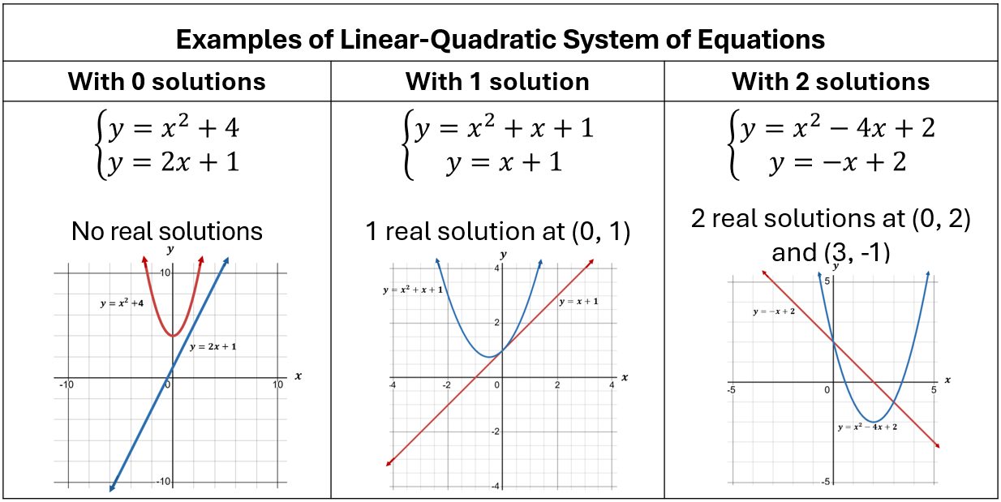

* A quadratic-quadratic system of equations may have zero, one, two, or an infinite number of solutions. See the examples below.

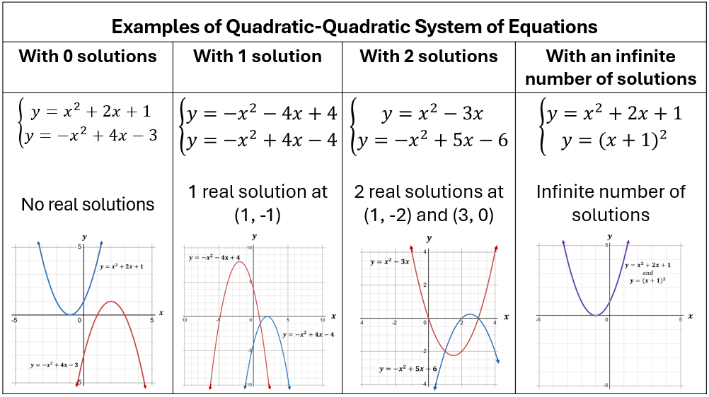

* Solving an equation or system of equations graphically with technology may lead to approximate solutions. The context of the problem should be considered when determining whether to report an exact or approximate solution.

###### Skills in Practice

While the five process goals are expected to be embedded in each standard, the Skills in Practice highlight the most prevalent process goals in relation to the content presented.

**Mathematical Problem Solving:** As students gain experience with absolute value equations and inequalities, quadratic equations and inequalities, systems of equations containing a quadratic expression, and equations containing rational algebraic expressions, they may have difficulty distinguishing between the types of equations and inequalities. In addition, they may struggle to determine when each type applies to a contextual situation and may have difficulty creating equations and inequalities to match contextual situations.

As students deepen their understanding of systems of equations, they may have difficulty creating a linear-quadratic system of equations or quadratic-quadratic system of equations to model a contextual situation or solving a system of equations presented in a context. Consider the following scenario.

A water fountain shoots a stream of water upward, and the height of the water, $y$, in meters, after $x$ seconds is modeled by the equation $y=-{2x}^{2}+8x+1$. At the same time, a bird flies in a straight line, starting 4 meters above the ground and rising at a steady rate of 1 meter per second. The bird’s height (in meters) after $x$ seconds is modeled by the equation $y=x+4$. At what time will the water and the bird be at the same height?

Students may be unsure how to solve this problem. Teachers should point out that both equations are written in the form “y = ”, so the two equations can be set to equal each other. Additionally, students could graph the system of equations by hand and then verify using technology such as Desmos. This will enable them to see that there are two points of intersection. As the bird continues its upward trajectory, it will intersect the water once as the stream goes up and once as the stream goes down. Students can then verify their solutions algebraically.

**Mathematical Reasoning:** As students deepen their understanding of systems of equations, they may demonstrate several common errors. Two examples are shown below.

* Consider the following system of equations: $\left\{\begin{aligned}y=x^{2}-2x+1 \\ y=3-x\end{aligned}\right.$

When solving this system of equations using substitution, students may substitute an expression for the wrong variable (e.g., in the above example, substituting $3-x$ for $x$ in the first equation would be incorrect). This error may indicate that students do not understand how to correctly use the substitution method when solving a system of equations. Teachers may want to show students that both equations are defined in terms of $x$ and set up as “ $y=$”. Therefore, students can set the two expressions equal to each other $(x^{2}-2x+1=3-x$) and solve for $x$. Additionally, it may be beneficial for students to graph the functions and verify using technology, such as Desmos, after solving the system of equations algebraically. When graphing the system, students will notice that the system of equations above has two points of intersection and thus, they should find two solutions.

* Consider the following system of equations: $\left\{\begin{aligned}y={(x-3)}^{2}-1 \\ y=-{\left(2x+9\right)}^{2}-5\end{aligned}\right.$

When determining the number of solutions for this system of equations, some students may incorrectly state that there are two solutions. This indicates that students believe that because the system consists of quadratic equations, the graphs must intersect in two locations and therefore, the number of solutions should be two. It would be beneficial to have students graph the system of equations using technology, such as Desmos, to represent the system visually to verify the correct number of solutions. As demonstrated by the graph below, this system of equations has 0 solutions because the graphs of the two equations do not intersect.

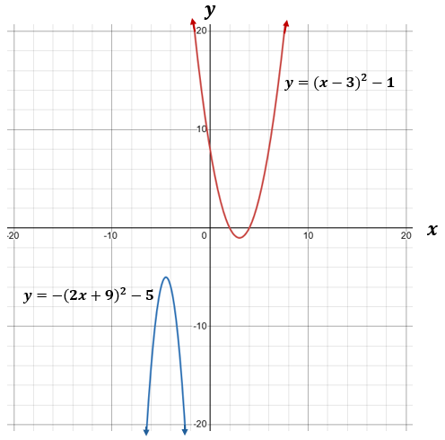

**Mathematical Representations:** Systems of equations can be represented graphically, with the solution set being the point(s) of intersection of the two equations. Consider the following example.

The graphs of functions $f(x)$ and $g(x)$ are shown below. How many solutions does the system appear to have?

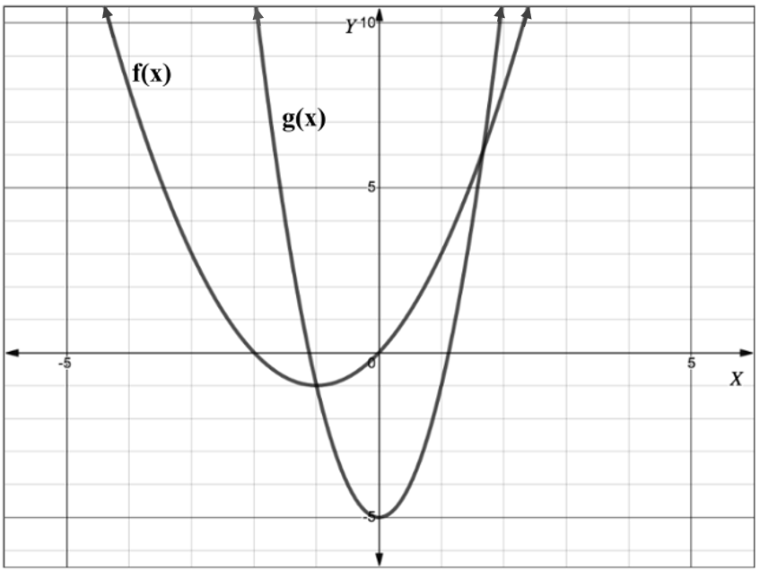

A common error is for students to state that there are 4 solutions to this system. This indicates that students are considering the *x*-intercepts as the solutions, rather than the points of intersection. Students should be encouraged to circle or highlight the points of intersection to help them identify the solutions to the system of equations. In the above example, there are two points of intersection and thus, there are two solutions.

###### Concepts and Connections

Concepts

Systems of quadratic equations can be used to model real-life contextual situations.

Connections

* *Within the grade level/course:*
  + A2.EI.1 – The student will represent, solve, and interpret the solution to absolute value equations and inequalities in one variable.
  + A2.EI.2 – The student will represent, solve, and interpret the solution to quadratic equations in one variable over the set of complex numbers and solve quadratic inequalities in one variable.
  + A2.EI.4 – The student will represent, solve, and interpret the solution to an equation containing rational algebraic expressions.
  + A2.EI.5 – The student will represent, solve, and interpret the solution to an equation containing a radical expression.
  + A2.EI.6 – The student will represent, solve, and interpret the solution to a polynomial equation.
* *Vertical Progression*:
  + A.EI.1 – The student will represent, solve, explain, and interpret the solution to multistep linear equations and inequalities in one variable and literal equations for a specified variable.
  + A.EI.2 – The student will represent, solve, explain, and interpret the solution to a system of two linear equations, a linear inequality in two variables, or a system of two linear inequalities in two variables.
  + A.EI.3 – The student will represent, solve, and interpret the solution to a quadratic equation in one variable.

###### Resources to Support Local Curriculum

* A list of approved textbooks and instructional materials is posted on the VDOE [website](https://www.doe.virginia.gov/teaching-learning-assessment/k-12-standards-instruction/mathematics/2024-mathematics-textbooks).
* [EOC Algebra 2 Formula Sheet](https://www.doe.virginia.gov/home/showpublisheddocument/56035/638581953490870000)(PDF)
* [Table of Standard Normal Probabilities](https://www.doe.virginia.gov/home/showpublisheddocument/20152/638043600831870000) (*z*-table) (PDF)

### A2.EI.4

##### The student will represent, solve, and interpret the solution to an equation containing rational algebraic expressions.

1. Students will demonstrate the following Knowledge and Skills:
2. Create an equation containing a rational expression to model a contextual situation.
3. Solve rational equations with real solutions containing factorable algebraic expressions algebraically and graphically. Algebraic expressions should be limited to linear and quadratic expressions.
4. Verify possible solution(s) to rational equations algebraically, graphically, and with technology to justify the reasonableness of answer(s). Explain the solution method and interpret solutions for problems given in context.
5. Justify why a possible solution to an equation containing a rational expression might be extraneous.

###### Understanding the Standard

* Equations that contain rational expressions can be used to represent, interpret, and solve contextual problems.
* Equations that contain rational expressions can be solved in a variety of ways.
* The process of solving equations that contain rational expressions can lead to extraneous solutions.
* An extraneous solution is a solution of the simplified form of an equation that does not satisfy the original equation. Use substitution to verify solutions. For example, consider the equation $\frac{x^{2}}{x+3}=\frac{9}{x+3}$. Solving this equation results in two solutions, $x=3$ or $x=-3$. However, substituting $x=-3$ into the original equation produces a 0 in the denominator, which is undefined. Therefore, $x=-3$ is an extraneous solution.
* The process used to solve an equation with a rational expression may lead to solving an equivalent equation containing a polynomial expression. In Algebra 2, these experiences should be limited to equivalent linear or quadratic equations.
* Solving an equation graphically with technology may lead to approximate solutions. The context of the problem should be considered when determining whether to report an exact or approximate solution.

###### Skills in Practice

While the five process goals are expected to be embedded in each standard, the Skills in Practice highlight the most prevalent process goals in relation to the content presented.

**Problem Solving:** As students gain experience with absolute value equations and inequalities, quadratic equations and inequalities, systems of equations containing a quadratic expression, and equations containing rational algebraic expressions, they may have difficulty distinguishing between the types of equations and inequalities. In addition, they may struggle to determine when each type applies to a contextual situation and may have difficulty creating equations and inequalities to match contextual situations.

As students deepen their understanding of equations that contain rational expressions, they may have difficulty creating an equation to model a contextual situation. Consider the following scenario.

A printer can complete a print job in $x$ hours. A second, faster printer can complete the same print job in $x-2$ hours. Working together, they can complete the job in 3 hours. What is the value of $x$?

Students may be unsure how to begin this problem. They may recognize that the two printers are working together, which represents addition, but may incorrectly represent the contextual situation as $x+\left(x-2\right)=3.$ Instead, students should understand that the work rate of each printer is represented by the rational expression $\frac{a}{b}, b≠0$, where $a$ represents the amount of work and $b$ represents the amount of time taken. Thus, the equation to represent the above contextual situation should be $\frac{1}{x}+\frac{1}{x-2}=\frac{1}{3}$. Another common error may occur when solving the example above by using the quadratic formula, resulting in two possible solutions, $x≈0.838$ hours or $x≈$ 7.162 hours. However, students should recognize that $x≈0.838$ is not a possible solution, as it would result in a negative number of hours for the second printer ( $x-2≈-1.162$ hours).

**Mathematical Reasoning:** As students build their proficiency with equations containing rational expressions, they may demonstrate common errors or misconceptions.

* Consider the following equation.

$\frac{-x+4}{2-x}+4x=\frac{2x+1}{2x+3}$.

As their first step, students may incorrectly simplify by factoring and reducing terms rather than common factors. In the example above, students may incorrectly try to simplify the equation to $\frac{4}{2}+4x=\frac{1}{3}$. This demonstrates that they removed $-x$ from the numerator and denominator of the first term on the left side of the equation, and they removed $2x$ from the numerator and the denominator from the right side of the equation. This error indicates that students may not understand that terms can only be simplified and reduced when written as a monomial expression and that a binomial expression cannot be simplified and reduced unless it is a common factor. Teachers should encourage students to circle the entire binomial factor. Additionally, teachers may wish to have students solve rational equations with less complex expressions that include monomial and binomial factors to ensure they understand when and how to properly simplify factors.

* Consider the following equation.

$$\frac{2x}{3x^{2}}+\frac{7x}{4} =5$$

A common error some students may make is to combine the denominators of two fractions without first finding a common denominator, incorrectly simplifying the above equation to $\frac{9x}{3x^{2}+4}=5$*.* This may indicate that students do not understand that the fractions must be rewritten as equivalent fractions using common denominators before combining and writing as one fraction. Students may also not understand how to find the least common multiple of different denominators. Teachers may want to provide additional practice solving rational equations that require students to find common denominators using algebraic expressions*.*

**Mathematical Representations:** A common student error is failing to check an equation for extraneous solutions. This may indicate that students assume all answers found are actual solutions to a problem. Consider the following equation.

$$\frac{x^{2}-4}{x-2}=x+2$$

Students may incorrectly state that the solutions are $x=2$ and $x=-2$. This indicates that students do not recognize $x=2$ as an extraneous solution because it will result in division by 0 in the original equation. Students may benefit from using a graphical approach to graph the related function. They can then check for extraneous solutions by exploring the restricted domain values. If students use technology to check for extraneous solutions, they should become familiar with how the technology program represents extraneous solutions. For example, when using Desmos, extraneous solutions are not visually apparent. Yet, when hovering over the point of the extraneous solution, a hole appears on the graph and the ordered pair is listed as $(x$- $value, undefined).$ See the example below, which models $f\left(x\right)=\frac{x^{2}-4}{x-2}$.

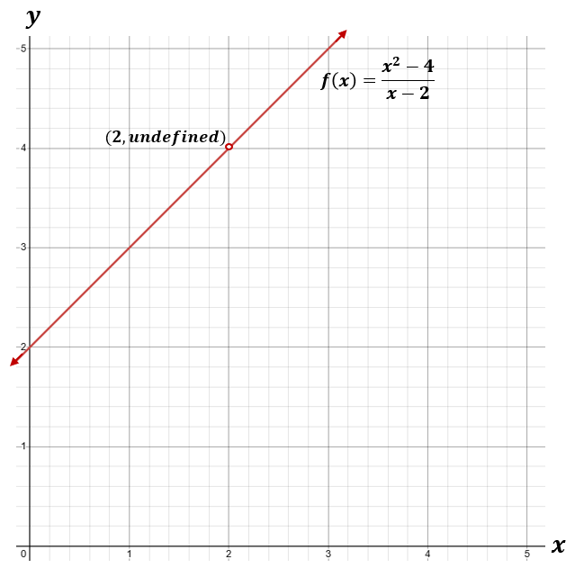

###### Concepts and Connections

Concepts

Rational equations can be used to model real-life contextual situations.

Connections

* *Within the grade level/course:*
  + A2.EI.1 – The student will represent, solve, and interpret the solution to absolute value equations and inequalities in one variable.
  + A2.EI.2 – The student will represent, solve, and interpret the solution to quadratic equations in one variable over the set of complex numbers and solve quadratic inequalities in one variable.
  + A2.EI.3 – The student will solve a system of equations in two variables containing a quadratic expression.
  + A2.EI.5 – The student will represent, solve, and interpret the solution to an equation containing a radical expression.
  + A2.EI.6 – The student will represent, solve, and interpret the solution to a polynomial equation.
* *Vertical Progression*:
  + A.EI.1 – The student will represent, solve, explain, and interpret the solution to multistep linear equations and inequalities in one variable and literal equations for a specified variable.
  + A.EI.3 – The student will represent, solve, and interpret the solution to a quadratic equation in one variable.

###### Resources to Support Local Curriculum

* A list of approved textbooks and instructional materials is posted on the VDOE [website](https://www.doe.virginia.gov/teaching-learning-assessment/k-12-standards-instruction/mathematics/2024-mathematics-textbooks).
* [EOC Algebra 2 Formula Sheet](https://www.doe.virginia.gov/home/showpublisheddocument/56035/638581953490870000)(PDF)
* [Table of Standard Normal Probabilities](https://www.doe.virginia.gov/home/showpublisheddocument/20152/638043600831870000) (*z*-table) (PDF)

### A2.EI.5

##### The student will represent, solve, and interpret the solution to an equation containing a radical expression.

1. Students will demonstrate the following Knowledge and Skills:
2. Solve an equation containing no more than one radical expression algebraically and graphically.
3. Verify possible solution(s) to radical equations algebraically, graphically, and with technology, to justify the reasonableness of answer(s). Explain the solution method and interpret solutions for problems given in context.
4. Justify why a possible solution to an equation with a square root might be extraneous.

###### Understanding the Standard

* Equations that contain a radical expression can be used to represent, interpret, and solve contextual problems.
* Equations that contain a radical expression can be solved in a variety of ways.
* Radical expressions may be converted to expressions using rational exponents.
* The process of solving equations that contain a radical expression can lead to extraneous solutions.
* An extraneous solution is a solution of the simplified form of an equation that does not satisfy the original equation. Use substitution to verify solutions. Consider the equation $\sqrt{x}=x-2$, which results in two solutions: $x=1$ or $x=4$. However, substituting $x=1$ into the original equation yields $\sqrt{1}=-1$. Thus, $x=1$ is an extraneous solution.
* The process used to solve an equation containing the square root of an algebraic expression and a linear expression may involve solving an equivalent quadratic equation.
* Solving an equation graphically with technology may lead to approximate solutions. The context of the problem should be considered when determining whether to report an exact or approximate solution.

###### Skills in Practice

While the five process goals are expected to be embedded in each standard, the Skills in Practice highlight the most prevalent process goals in relation to the content presented.

**Mathematical Representations:** A common student error is failing to check an equation for extraneous solutions. This may indicate that students assume all answers found are actual solutions to a problem. Consider the following equation.

$$\sqrt{x-1}=x-3$$

When solving algebraically, students may get a result of $x=2$ and $x=5$. However, when checking their solutions, they will find that substituting $x=2$ into the original equation results in $1=-1$, and thus, $x=2$ is an extraneous solution. Students can verify these solutions using a graphical approach, by graphing the related function of each side of the equation. This will show that $x=5$ is a valid solution to the equation while $x=2$ is not. See the graph below.

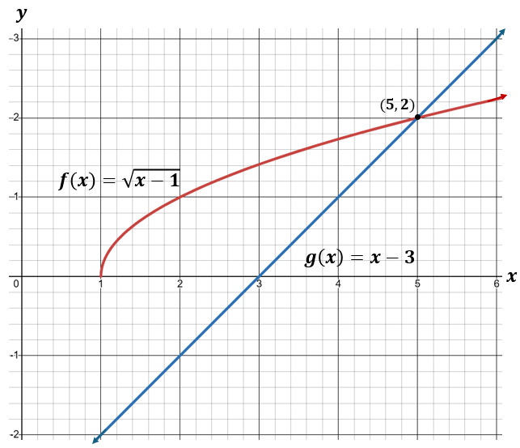

**Mathematical Connections:** When solving radical equations, students should make connections between algebraic representations of the equation and graphical representations of the related functions.

* Which graph could be used to verify the solution of $x+\sqrt{x}=6$?

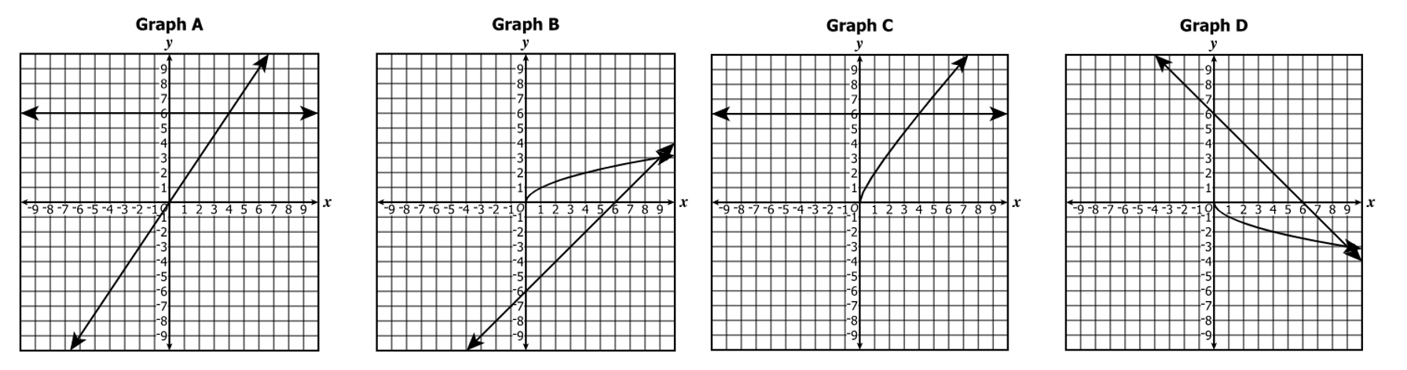

Students should be encouraged to solve the equation algebraically first, resulting in $x=4$ and $x=9$. However, upon checking their solutions, students will see that substituting $x=9$ into the original equation results in a contradiction, $12=6$. Thus, $x=9$ is an extraneous solution and will not provide the $x$-coordinate of a point of intersection.

Students should understand that they can rearrange the given equation to produce different yet equivalent equations, and the graphs of these related functions could also be used to determine the solution of the equation. Students should make connections between the graphs of these related functions.

* + Example 1: $f\left(x\right)=x+\sqrt{x}$ and $g\left(x\right)=6$
  + Example 2: $h\left(x\right)=x+\sqrt{x}-6$ and $k\left(x\right)=0$
  + Example 3: $m\left(x\right)=x$ and $n\left(x\right)=6-\sqrt{x}$

In the graphs above, the related functions used were $f\left(x\right)=x+\sqrt{x}$ and $g\left(x\right)=6$, which are represented in Graph C. However, students may incorrectly choose Graph A because it graphs the related functions $f(x)=x$ and $g(x)=6$. Students should consider the entire side of the equation when determining which graph of the related functions is the best representation.

**Mathematical Reasoning:** As students build their proficiency with equations containing a radical expression, they may demonstrate common errors or misconceptions.

* Consider the equation $12-4\sqrt[3]{x-5}=0$. When solving this equation, there are several common errors students may make. First, students may not completely isolate the radical on one side of the equation, resulting in $-4\sqrt[3]{x-5}=-12$. While this is not an error, neglecting to isolate the radical can result in a more complex equation and lead to more complicated computations. Students should be encouraged to isolate the radical on one side of the equation first. Another common mistake is isolating the radical correctly, resulting in $\sqrt[3]{x-5}=3$, but then squaring both sides rather than cubing both sides. Students should pay attention to the index of the radical. Teachers may wish to encourage students to circle or highlight the index of the radical. Finally, students may demonstrate computation errors, such as dividing $-12$ by $-4$ and getting an incorrect quotient of $-3$, or incorrectly determining that $3^{3}=6$ or $3^{3}=9$. Students who struggle with solving equations containing a radical expression may benefit from solving radical equations with less complexity such as $\sqrt{x-1}-2=0.$
* Consider the equation $\sqrt{2x^{2}+1}=1-x$. When solving, students may incorrectly square each of the two terms on the right separately instead of squaring the binomial expression on the right side of the equation. This would result in an incorrect simplification of $({1-x)}^{2}$ as $1^{2}-x^{2},$ rather than the correct simplification of $x^{2}-2x+1.$ This error may indicate that a student does not understand how to properly square a binomial. Using a graphical approach to solving this equation by graphing the related functions $f\left(x\right)=({1-x)}^{2}$ and $\left(x\right)=1-x^{2},$ and comparing the two graphs can also help students verify solutions.

###### Concepts and Connections

Concepts

Radical equations can be used to model real-life contextual situations.

Connections

* *Within the grade level/course:*
  + A2.EI.1 – The student will represent, solve, and interpret the solution to absolute value equations and inequalities in one variable.
  + A2.EI.2 – The student will represent, solve, and interpret the solution to quadratic equations in one variable over the set of complex numbers and solve quadratic inequalities in one variable.
  + A2.EI.3 – The student will solve a system of equations in two variables containing a quadratic expression.
  + A2.EI.4 – The student will represent, solve, and interpret the solution to an equation containing rational algebraic expressions.
  + A2.EI.6 – The student will represent, solve, and interpret the solution to a polynomial equation.
* *Vertical Progression*:
  + A.EI.1 – The student will represent, solve, explain, and interpret the solution to multistep linear equations and inequalities in one variable and literal equations for a specified variable.
  + A.EI.2 – The student will represent, solve, explain, and interpret the solution to a system of two linear equations, a linear inequality in two variables, or a system of two linear inequalities in two variables.
  + A.EI.3 – The student will represent, solve, and interpret the solution to a quadratic equation in one variable.

###### Resources to Support Local Curriculum

* A list of approved textbooks and instructional materials is posted on the VDOE [website](https://www.doe.virginia.gov/teaching-learning-assessment/k-12-standards-instruction/mathematics/2024-mathematics-textbooks).
* [EOC Algebra 2 Formula Sheet](https://www.doe.virginia.gov/home/showpublisheddocument/56035/638581953490870000)(PDF)
* [Table of Standard Normal Probabilities](https://www.doe.virginia.gov/home/showpublisheddocument/20152/638043600831870000) (*z*-table) (PDF)
* Radical Equations Exemplar Mathematics Instructional Plan ([Word](https://www.doe.virginia.gov/home/showpublisheddocument/51905/638398751103870000) | [PDF](https://www.doe.virginia.gov/home/showpublisheddocument/51907/638398751109330000))

### A2.EI.6

##### The student will represent, solve, and interpret the solution to a polynomial equation.

1. Students will demonstrate the following Knowledge and Skills:
2. Determine a factored form of a polynomial equation, of degree three or higher, given its zeros or the *x*-intercepts of the graph of its related function.
3. Determine the number and type of solutions (real or imaginary) of a polynomial equation of degree three or higher.
4. Solve a polynomial equation over the set of complex numbers.
5. Verify possible solution(s) to polynomial equations of degree three or higher algebraically, graphically, and with technology to justify the reasonableness of answer(s). Explain the solution method and interpret solutions in context.

###### Understanding the Standard

* Polynomial equations can be used to represent, interpret, and solve contextual problems.
* Polynomial equations can be solved in a variety of ways.
* The degree of a polynomial equation is the largest power or exponent of a variable in the equation.
* The Fundamental Theorem of Algebra states that, including complex and repeated solutions, an $n^{th}$ degree polynomial equation has exactly $n$ roots (solutions).
* Solutions of polynomial equations may be real or imaginary.
* Imaginary solutions occur in conjugate pairs.
* Polynomial equations may have fewer distinct roots than the degree of the polynomial. In these situations, a root may have “multiplicity.” For instance, the polynomial equation $y=x^{3}-6x^{2}+9x$ has two identical factors, $(x-3)$, and one other factor, $x$. This polynomial equation has two distinct, real roots, one with a multiplicity of 2.
* Solving an equation graphically with technology may lead to approximate solutions. The context of the problem should be considered when determining whether to report an exact or approximate solution.
* The zeros of a function *f(x)* are the values of *x* where the function is equal to 0. The zeros of a function are also the solutions or roots of the related function.
* The *x*-intercepts of a graph are located where the graph crosses the *x-*axis and where *f(x)* = 0.
* The Zero Product Property states that if $ab=0$, then $a=0$ or $b=0.$ For example, given $\left(x+3\right)\left(x-4\right)=0$, then $x+3=0$ or $x-4=0$. Thus, $x=-3$ or $x=-4$. These are the solutions or roots of the equation.
* The Factor Theorem states that if *f(x)* is a polynomial of degree *n* greater than or equal to 1, and *a* is any real number, then *x – a* is a factor of *f(x)* if *f(a)* = 0.
* In Algebra 2, students may benefit from experiences with multiple methods, to include, but not limited to, long or synthetic division to solve polynomial equations.

###### Skills in Practice

While the five process goals are expected to be embedded in each standard, the Skills in Practice highlight the most prevalent process goals in relation to the content presented.

**Mathematical Problem Solving:** As students solve polynomial equations, they often struggle to determine the number of real solutions. For example, consider the following equation.

$$x^{4}-5x^{3}+10x^{2}-20x+24=0$$

Students should solve this equation algebraically first. One method students may use to solve this problem is synthetic division. Using synthetic division to divide the polynomial equation by $\left(x-2\right)$ to determine whether $(x-2)$ is a factor is modeled below:

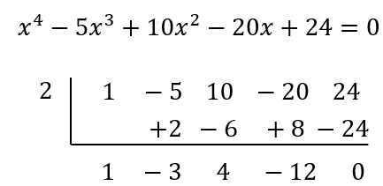

This results in $\left(x-2\right)\left(x^{3}-3x^{2}+4x-12\right)=0.$ Students may then use synthetic division again or they may use a grouping strategy to further factor $x^{3}-3x^{2}+4x-12$. When solving algebraically, students should factor the polynomial into $(x-2)(x-3)(x^{2}+4)=0.$ Students should recognize that there are two real solutions, $x=2$ and $x=3$, and two complex solutions, $x=2i$ and $x=-2i$. However, when asked to determine the number of real solutions, students may incorrectly state that there are four real solutions. This indicates that students identified the degree of the polynomial as the number of real solutions. The Fundamental Theorem of Algebra should be reviewed with students. A strategy that could be used is to create a quadratic or cubic function with two imaginary solutions to show that the degree is equal to the number of all the solutions and not always the number of real solutions. Additionally, students can verify the number of solutions by representing the equation graphically. This will provide a visual that reinforces that this equation only has two real solutions, as modeled below.

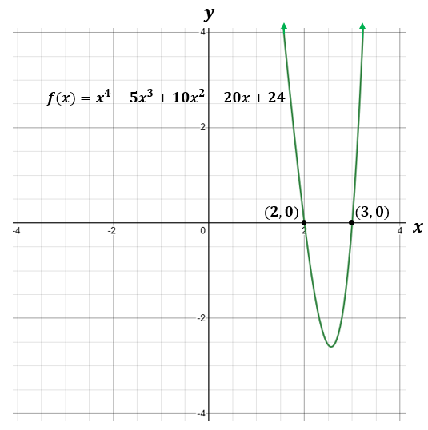

**Mathematical Representations:** Students should be proficient at determining the number and type of solutions of a polynomial equation. Consider the example below.

The graph of the related function of a polynomial equation, $f(x)$, is shown below. Determine the number and type of solutions of the polynomial equation.

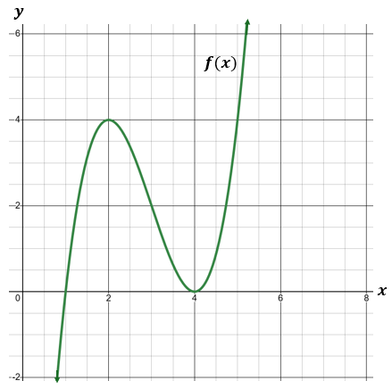

From the graph, students should recognize that there is a zero at $x=1$, with a multiplicity of 1 because it crosses the $x$-axis, and a zero at $x=4$, with a multiplicity of 2 because it touches the $x$-axis but does not cross it. Thus, the equation has three real solutions, counting multiplicities.

###### Concepts and Connections

Concepts

Polynomial equations can be used to model real-life contextual situations.

Connections

* *Within the grade level/course:*
  + A2.EI.1 – The student will represent, solve, and interpret the solution to absolute value equations and inequalities in one variable.
  + A2.EI.2 – The student will represent, solve, and interpret the solution to quadratic equations in one variable over the set of complex numbers and solve quadratic inequalities in one variable.
  + A2.EI.3 – The student will solve a system of equations in two variables containing a quadratic expression.
  + A2.EI.4 – The student will represent, solve, and interpret the solution to an equation containing rational algebraic expressions.
  + A2.EI.5 – The student will represent, solve, and interpret the solution to an equation containing a radical expression.
* *Vertical Progression*:
  + A.EI.1 – The student will represent, solve, explain, and interpret the solution to multistep linear equations and inequalities in one variable and literal equations for a specified variable.
  + A.EI.2 – The student will represent, solve, explain, and interpret the solution to a system of two linear equations, a linear inequality in two variables, or a system of two linear inequalities in two variables.
  + A.EI.3 – The student will represent, solve, and interpret the solution to a quadratic equation in one variable.

###### Resources to Support Local Curriculum

* A list of approved textbooks and instructional materials is posted on the VDOE [website](https://www.doe.virginia.gov/teaching-learning-assessment/k-12-standards-instruction/mathematics/2024-mathematics-textbooks).
* [EOC Algebra 2 Formula Sheet](https://www.doe.virginia.gov/home/showpublisheddocument/56035/638581953490870000)(PDF)
* [Table of Standard Normal Probabilities](https://www.doe.virginia.gov/home/showpublisheddocument/20152/638043600831870000) (*z*-table) (PDF)

## Functions

Functions represent a main tenet of algebra. A thorough understanding of functions can be derived from skills obtained from exploring operations, expressions, and equations. The knowledge of functions allows students to transition equations from algebraic to graphical representations using coordinate methods. Function operations and transformations are connected to skills obtained from the exploration of expressions and equations. Mastery of functions will be required for successful completion of advanced mathematics courses, beyond Algebra 2.

Throughout Algebra 2, students will investigate, analyze, and compare square root, cube, root, rational, exponential, and logarithmic function families, algebraically and graphically, using transformations. Additionally, students will investigate, analyze, and compare characteristics of square root, cube root, rational, polynomial, exponential, logarithmic, and piecewise-defined functions algebraically and graphically.

### A2.F.1

##### The student will investigate, analyze, and compare square root, cube root, rational, exponential, and logarithmic function families, algebraically and graphically, using transformations.

1. Students will demonstrate the following Knowledge and Skills:
2. Distinguish between the graphs of parent functions for square root, cube root, rational, exponential, and logarithmic function families.
3. Write the equation of a square root, cube root, rational, exponential, and logarithmic function, given a graph, using transformations of the parent function, including *f*(*x*) + *k*; *f*(*kx*); *f*(*x* + *k*); and *kf*(*x*), where *k* is limited to rational values. Transformations of exponential and logarithmic functions, given a graph, should be limited to a single transformation.
4. Graph a square root, cube root, rational, exponential, and logarithmic function, given the equation, using transformations of the parent function including *f*(*x*) + *k*; *f*(*kx*); *f*(*x* + *k*); and *kf*(*x*), where *k* is limited to rational values. Use technology to verify transformations of the functions.
5. Determine when two variables are directly proportional, inversely proportional, or neither, given a table of values. Write an equation and create a graph to represent a direct or inverse variation, including situations in context.
6. Compare and contrast the graphs, tables, and equations of square root, cube root, rational, exponential, and logarithmic functions.

###### Understanding the Standard

* A function is a relationship between two quantities in which every input corresponds to exactly one output (i.e., each element in the domain is paired with a unique element of the range).
* Function notation is written as *f(x)*, which is read as “the value of *f* at *x,*” or “*f* of *x.”* Other letters may be used to name and write functions (e.g., *g(x), h(x), t(x)*).Connections between multiple representations (graphs, tables, and equations) of a function can be made.
* The transformation of a function, called a pre-image, changes the size, shape, and/or position of the function to a new function, called the image.
* Function families consist of a parent function and all transformations of the parent function.
* The graph of a parent function is an anchor graph from which other graphs are derived using transformations.
* The graphs of parent functions for square root, cube root, rational, exponential, and logarithmic function families are shown in the table below.

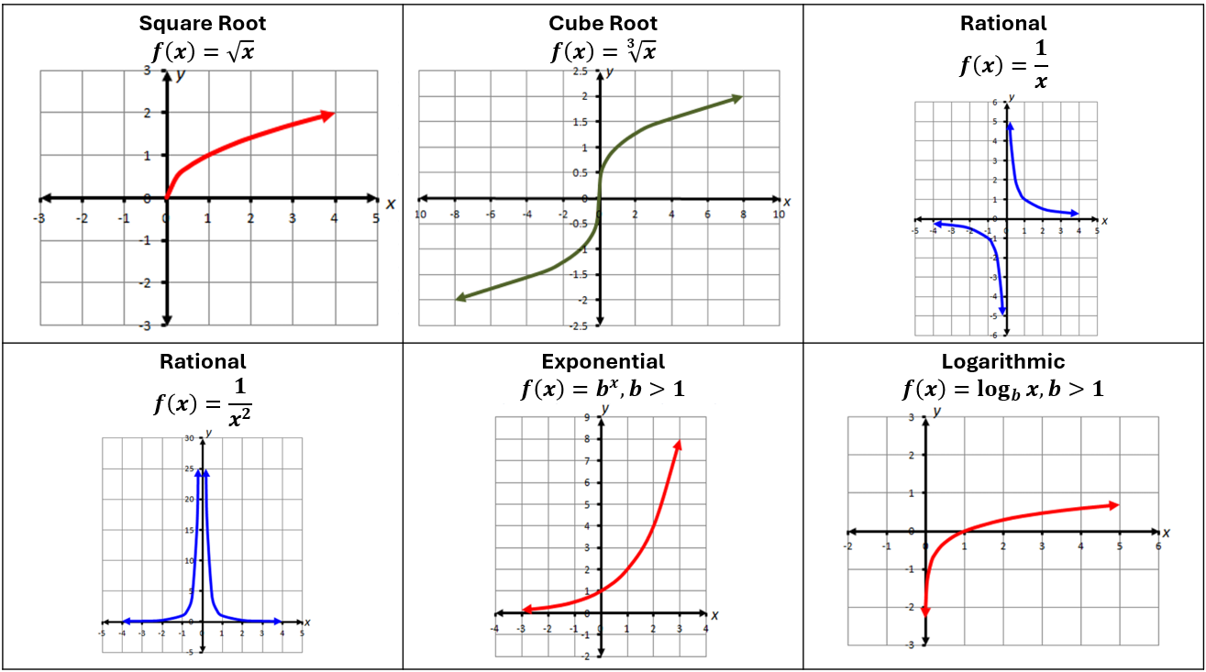

* The graphs of parent functions for other common function families are shown in the table below.

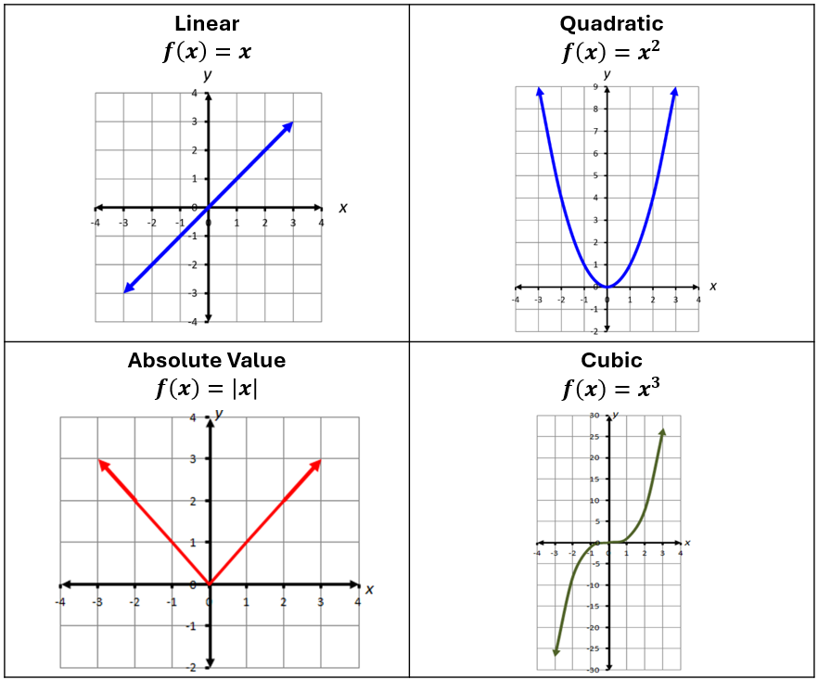

* The graphs/equations for a family of functions can be determined using a transformational approach.
* Transformations of functions act in a similar way as transformations on plane figures which students studied in Geometry and middle school mathematics.
* Transformations of graphs include:
* Translations (vertical and/or horizontal shifting of a graph), which are represented by the function notation $f\left(x\right)+k,$ and $f(x+k)$, respectively;
* Reflection over the *y*-axis, which is represented by the function notation $f(-x)$;
* Reflection over the *x*-axis, which is represented by the function notation $-f(x)$; and
* Dilations (horizontal and/or vertical stretching and compressing of graphs), which are represented by the function notation $f(kx)$ and $kf(x)$, respectively. Students should have opportunities to discover the effect on the dilation when $k>0$ and when $k<0$ (to include rational numbers).
* Examples of various transformations of graphs are shown below.

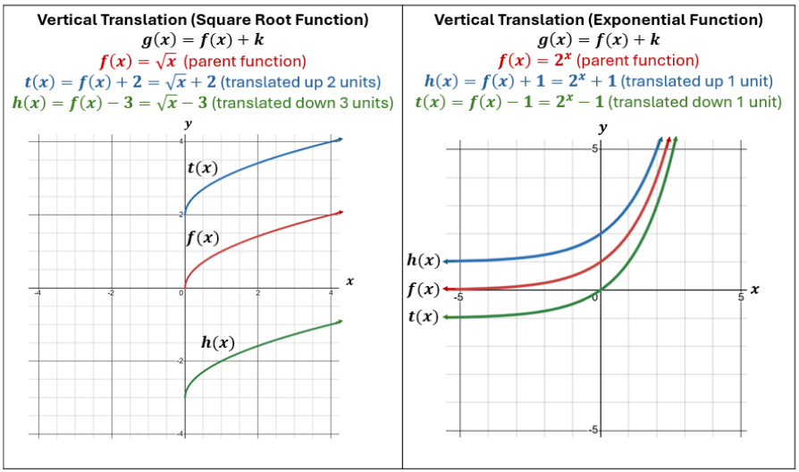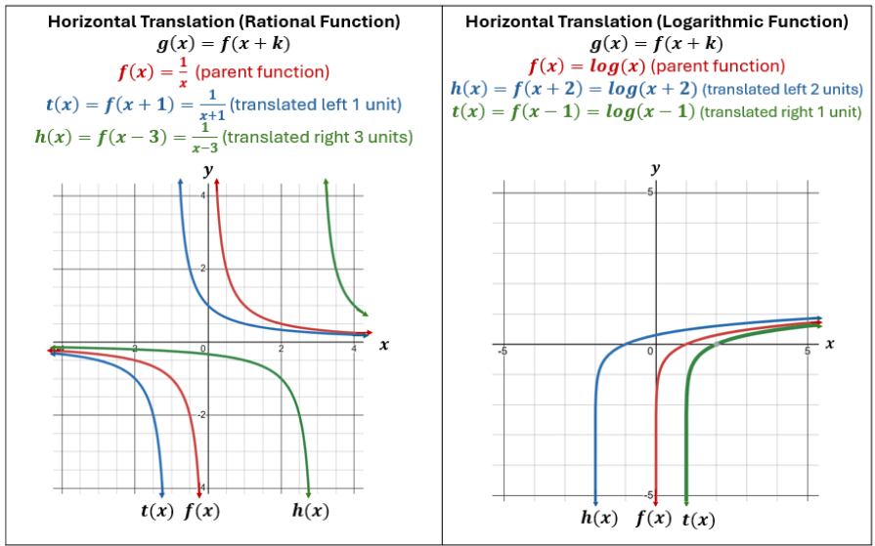

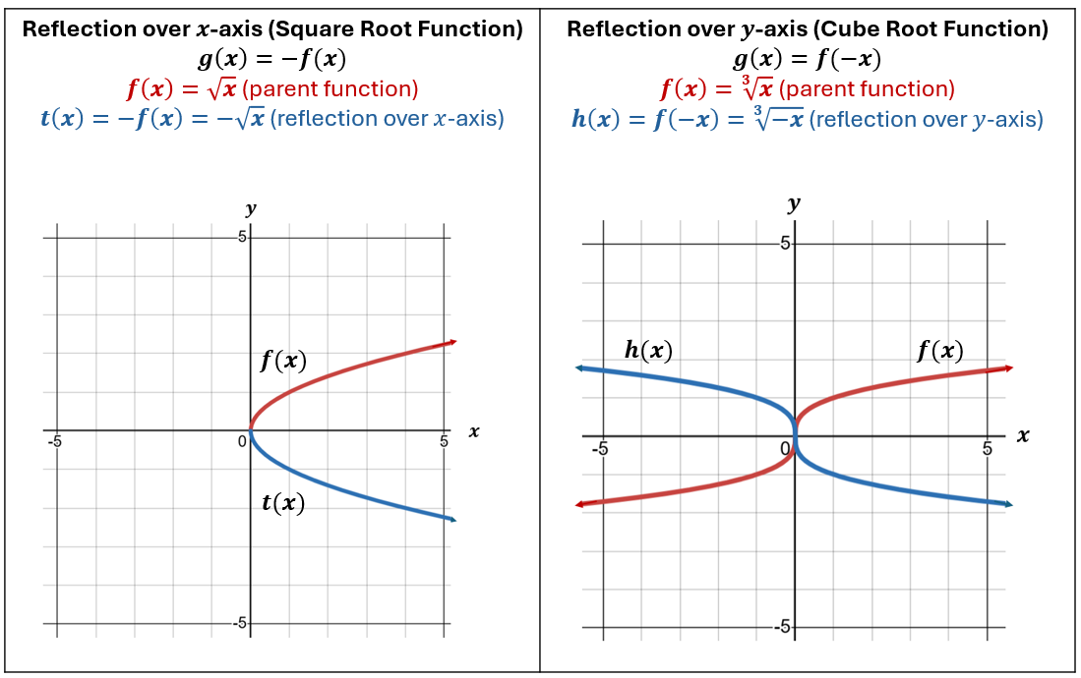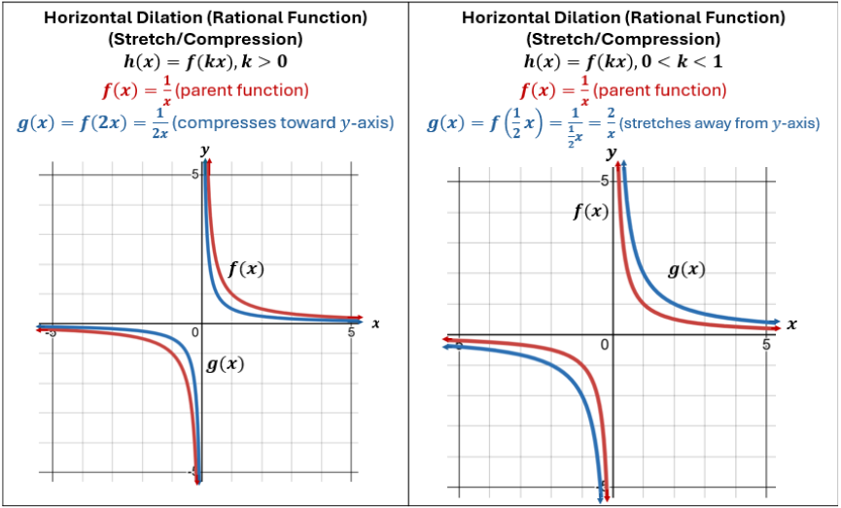

Image on the left shows vertical dilation of a cube root function, where the function compresses toward the x-axis. Image on the right shows vertical dilation of a cube root function where the function stretches away from the x-axis.


* Two variables are directly proportional when there exists a linear relationship that represents a proportional relationship between the two quantities. If $y$ is directly proportional to $x$, then $y=kx,$ where $k$ does not equal 0. This is known as a direct variation.
* The constant of proportionality (*k*) in a direct variation is represented by the ratio of the dependent variable to the independent variable. This is also referred to as the constant of variation.
* A direct variation represents a linear relationship, where the constant of proportionality $(k)$ is the slope of the line and the *y-*intercept is zero. A direct variation can be represented graphically by a line passing through the origin. See the example below.

Direct Variation Example, includes two column chart with first column labeled x and second column labeled y. Column labeled x includes -2, -1, 0, 1, 2. Column labeled y includes -6, -3, 0, 3, 6. Image includes coordinate plane with line y=-3x marked.


* Two variables are inversely proportional when the relationship between the two quantities is represented by a rational function. If $y$ is inversely proportional to $x$, then $y=\frac{k}{x}$. This is known as an inverse variation.
* The constant of proportionality ($k$) in an inverse variation is represented by the product of the dependent variable and the independent variable. This is also referred to as the constant of variation.
* When presented graphically, an inverse variation will be represented by two curves that are reflections of each other. See the example below.

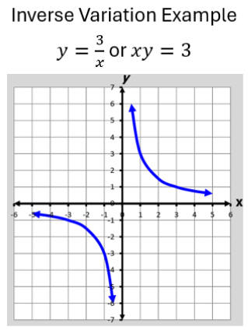

* The value of the constant of proportionality is typically positive when applied in contextual situations.
* Contextual situations involving direct and inverse variation occur in Chemistry.

###### Skills in Practice

While the five process goals are expected to be embedded in each standard, the Skills in Practice highlight the most prevalent process goals in relation to the content presented.

**Mathematical Problem Solving:** Students should have opportunities to solve contextual problems with direct variation and inverse variation. Consider the following scenario.

Assuming temperature remains constant, the volume of a gas, *V,* varies inversely as its pressure, *P*.

1. What is the constant of proportionality if a container has a volume of 6 liters under a pressure of 220 psi?
2. What is the volume of the gas when the pressure increases to 330 psi?

Students may calculate the correct constant of proportionality, however a common error that some students may make is to inadvertently switch the values of the increased pressure and the constant of proportionality when calculating the new volume, resulting in an incorrect equation of $V=\frac{330}{1320}$ and leading to an incorrect solution of 0.25 liters. Instead, students should have used the equation $V=\frac{1320}{330}$ to solve for the volume, resulting in a correct volume of 4 liters. This error may indicate that students recognize that as the pressure increases, the volume will decrease, but do not recognize the role of the constant of variation in the inverse relationship. Teachers may wish to provide additional ways to represent the inverse variation, such as using tables or graphs, to recognize the relationship between the values of the two quantities based on the constant of proportionality.

**Mathematical Reasoning:** Students may have difficulty determining whether an equation represents direct or inverse variation. Consider the following equations:

$gh=-5$

$a=\frac{b}{10}$

$\frac{x}{y}=4.65$

A common error is for students to assume that equations containing a fraction must represent inverse variation and those without a fraction must be direct. This could lead to an incorrect assertion that the first equation represents a direct variation, while the second and third equations represent inverse variations. This may indicate that students are unable to distinguish how the operations between the variables in the equation determine the type of relationship that exists. Teachers may want to compare direct and inverse variation equations and encourage students to write the equations using an equivalent form. For example, $gh=-5$ can be written as $g=-\frac{5}{h}$, which represents an inverse variation; $a=\frac{b}{10}$ can be written as $10a=b$, which represents a direct variation; and $\frac{x}{y}=4.65$ can be written as $x=4.65y$, which represents a direct variation.

**Mathematical Representations:** Students should be familiar with the parent functions of various types of functions. They will benefit from opportunities to group functions that belong to the same family given a variety of function types written in algebraic form. Consider the example below.

* The graph of *f(x)* is shown. Select each function that belongs to this same family.

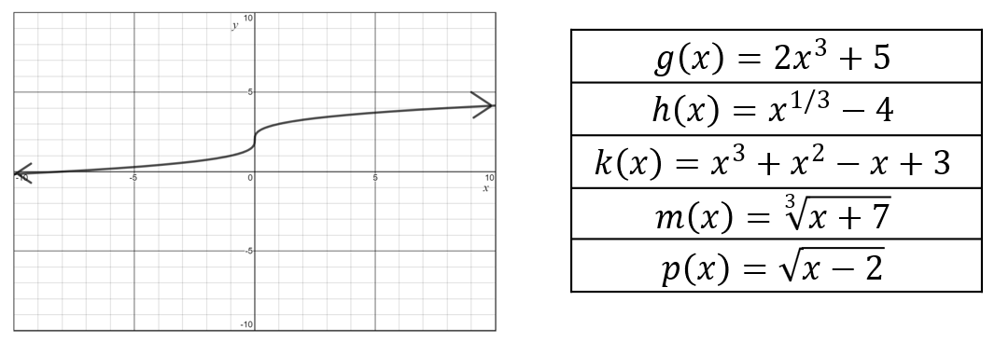

A common misconception is for students to confuse cubic and cube root functions. This may lead them to incorrectly select functions $g(x)$ and $k(x).$ This could indicate the student did not consider the differing rates at which these functions increase. A potential strategy would be for students to identify points on the graph and then make a table of values for several of these functions.

**Mathematical Connections:** Students should have opportunities to investigate, analyze, and compare various function families (algebraically and graphically) using transformations.

* Students should be proficient at recognizing the parent function of a function family and should be able to compare characteristics of function families. As students develop their understanding of function families, students may demonstrate several misconceptions.
  + Students may have difficulty recognizing similarities and differences between function families. One common misconception is that students may believe that logarithmic functions have a restricted range. This could indicate that students do not have a strong understanding of the definition of a logarithm and its inverse relationship with exponential functions. One potential strategy is to have students make a table of values for the graph and see which function family will best fit the values.
  + Another common misconception is to misinterpret how the parameters of the equation of a transformed function are affected by a horizontal translation. Consider a graph of the function $f\left(x\right)=x^{3}$. The function is then translated three units to the right and one unit up, creating $g\left(x\right)$. A student may incorrectly state that the new function $g\left(x\right)={(x+3)}^{3}+1$, which indicates that the student has mistaken a horizontal translation to the right with a positive addend for *x*. To support student understanding, teachers could have students use technology, such as Desmos, to graph a function $f\left(x\right)={(x+a)}^{3}+b$, creating *a* and *b* as sliders, and then allowing students to explore the translation results as the value of the slider changes. They could also examine the roles of *a* and *b* separately to see which is related to each type of translation (horizontal versus vertical). Students could also use Desmos to explore the relationship between *x* and *y* using a table.

###### Concepts and Connections

Concepts

Exponential, logarithmic, square root, cube root, and rational functions are used to model daily contextual experiences.

Connections

* *Within the grade level/course:*
  + A2.F.2 – The student will investigate and analyze characteristics of square root, cube root, rational, polynomial, exponential, logarithmic, and piecewise-defined functions algebraically and graphically.
* *Vertical Progression*:
  + 8.PFA.2 – The student will determine whether a given relation is a function and determine the domain and range of a function.
  + A.F.1 – The student will investigate, analyze, and compare linear functions algebraically and graphically, and model linear relationships.
  + A.F.2 – The student will investigate, analyze, and compare characteristics of functions, including quadratic and exponential functions, and model quadratic and exponential relationships.

###### Resources to Support Local Curriculum

* A list of approved textbooks and instructional materials is posted on the VDOE [website](https://www.doe.virginia.gov/teaching-learning-assessment/k-12-standards-instruction/mathematics/2024-mathematics-textbooks).
* [EOC Algebra 2 Formula Sheet](https://www.doe.virginia.gov/home/showpublisheddocument/56035/638581953490870000)(PDF)
* [Table of Standard Normal Probabilities](https://www.doe.virginia.gov/home/showpublisheddocument/20152/638043600831870000) (*z*-table) (PDF)
* Types of Variation Exemplar Mathematics Instructional Plan ([Word](https://www.doe.virginia.gov/home/showpublisheddocument/51909/638398751114800000) | [PDF](https://www.doe.virginia.gov/home/showpublisheddocument/51911/638398751119800000))

### A2.F.2

##### The student will investigate and analyze characteristics of square root, cube root, rational, polynomial, exponential, logarithmic, and piecewise-defined functions algebraically and graphically.

1. Students will demonstrate the following Knowledge and Skills:
2. Determine and identify the domain, range, zeros, and intercepts of a function presented algebraically or graphically, including graphs with discontinuities.
3. Compare and contrast the characteristics of square root, cube root, rational, polynomial, exponential, logarithmic, and piecewise-defined functions.
4. Determine the intervals on which the graph of a function is increasing, decreasing, or constant.
5. Determine the location and value of absolute (global) maxima and absolute (global) minima of a function.
6. Determine the location and value of relative (local) maxima or relative (local) minima of a function.
7. For any value, *x*, in the domain of *f*, determine *f*(*x*) using a graph or equation. Explain the meaning of *x* and *f*(*x*) in context, where applicable.
8. Describe the end behavior of a function.
9. Determine the equations of any vertical and horizontal asymptotes of a function using a graph or equation (rational, exponential, and logarithmic).
10. Determine the inverse of a function algebraically and graphically, given the equation of a linear or quadratic function (linear, quadratic, and square root). Justify and explain why two functions are inverses of each other.
11. Graph the inverse of a function as a reflection over the line *y* = *x*.
12. Determine the composition of two functions algebraically and graphically.

###### Understanding the Standard

* Functions may be used to represent contextual situations.
* Functions describe the relationship between two variables where each input is paired to a unique output.
* Function notation is written as *f(x)*, which is read as “the value of *f* at *x,*” or “*f* of *x.”* Other letters may be used to name and write functions (e.g., *g(x), h(x), t(x)*).Connections between multiple representations (graphs, tables, and equations) of a function can be made.
* A piecewise-defined function is a function with multiple definitions depending upon the value of the input (i.e., the function behaves differently for different inputs). An example of a piecewise-defined function is below.

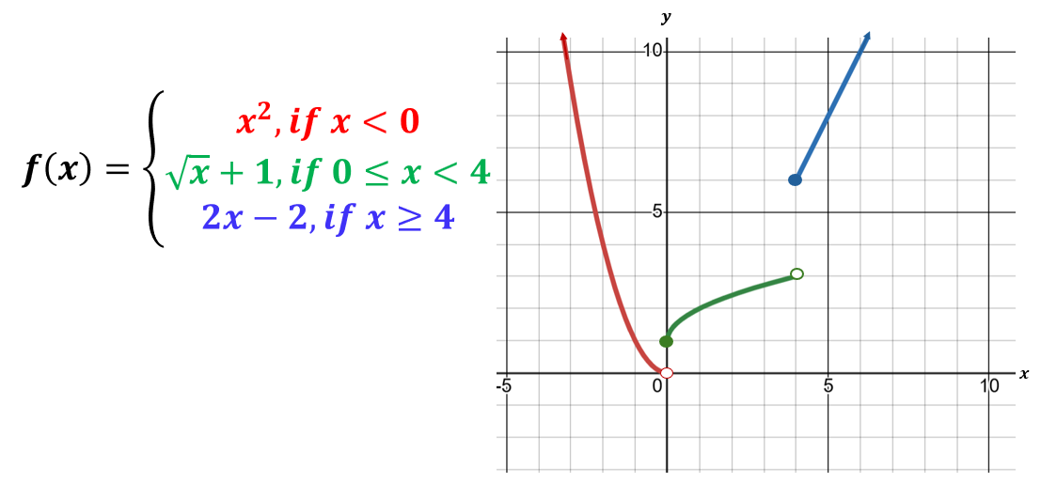

* The domain of a function is the set of all possible values of the independent variable.
* The range of a function is the set of all possible values of the dependent variable.
* The piecewise-defined function, *g(x),* is defined and represented below. The domain of *g(x)* is all real numbers, and the range of *g(x)* is all real numbers greater than -1.

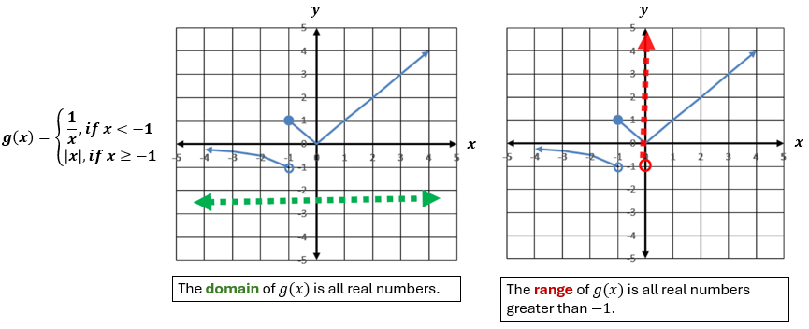

* Given *f* is a function: for each *x* in the domain of *f*, *x* is a member of the input of the function *f*, *f(x)* is a member of the output of *f*, and the ordered pair (*x*, *f(x)*) is a member of *f*. In other words, *f(x)* represents values of the range and *x* represents values of the domain.
* The domain or range of a function may be restricted algebraically, graphically, or by the contextual situation represented by a function.
* Given a polynomial function *f(x)*, the following statements are equivalent for any real number, *k*, such that *f(k)* = 0:
  + *k* is a zero of the polynomial function *f(x)* located at (*k*, 0);
  + *k* is a solution or root of the polynomial equation *f(x)* = 0;
  + the point (*k*, 0) is an *x*-intercept for the graph of *f(x)* = 0; and
  + (*x* – *k*) is a factor of *f(x)*.
* A function is said to be continuous if the function is continuous at every point in its domain. A function can also be continuous on an interval if its graph has no jumps or holes in that interval. See the examples below.

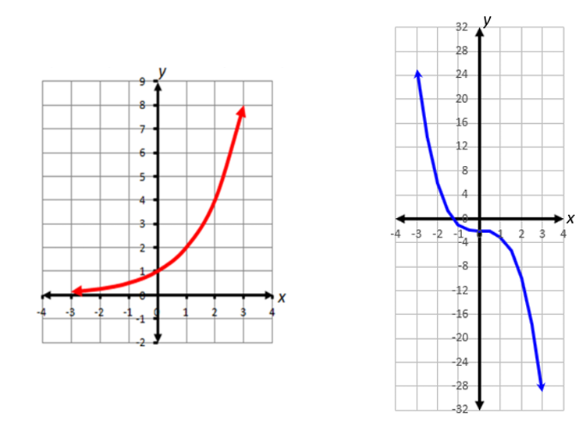

* Discontinuous domains and ranges include those with removable (holes) and nonremovable (asymptotes) discontinuities. Examples of discontinuities are shown in the image below.

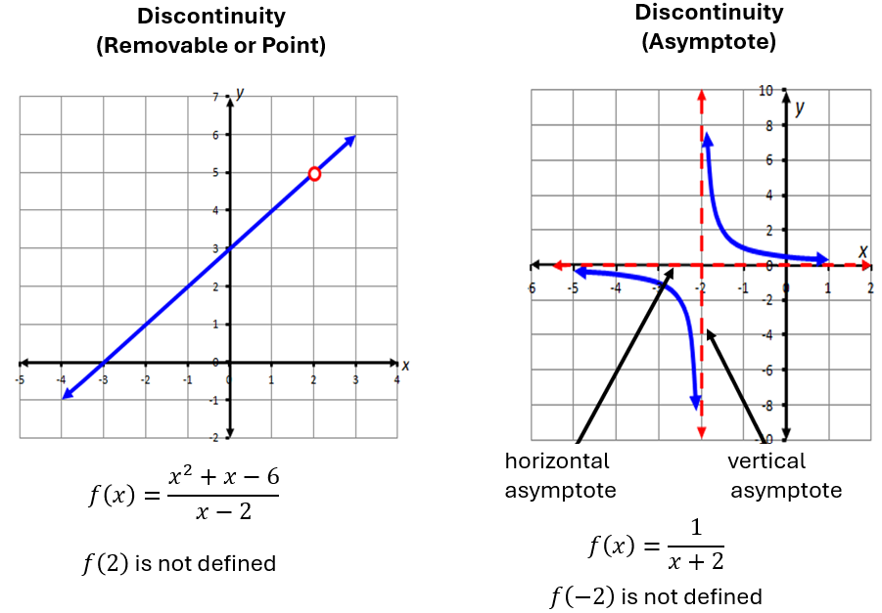

* A function can be described as increasing, decreasing, or constant over a specified interval or over the entire domain of the function.
* A function, *f(x)*, is increasing over an interval if the values of *f(x)* consistently increase over the interval as the *x* values increase.
* A function, *f(x)*, is decreasing over an interval if the values of *f(x)* consistently decrease over the interval as the *x* values increase.
* A function, *f(x)*, is constant over an interval if the values of *f(x)* remain constant over the interval as the *x* values increase.
* Examples of increasing, decreasing, and constant functions are shown below.

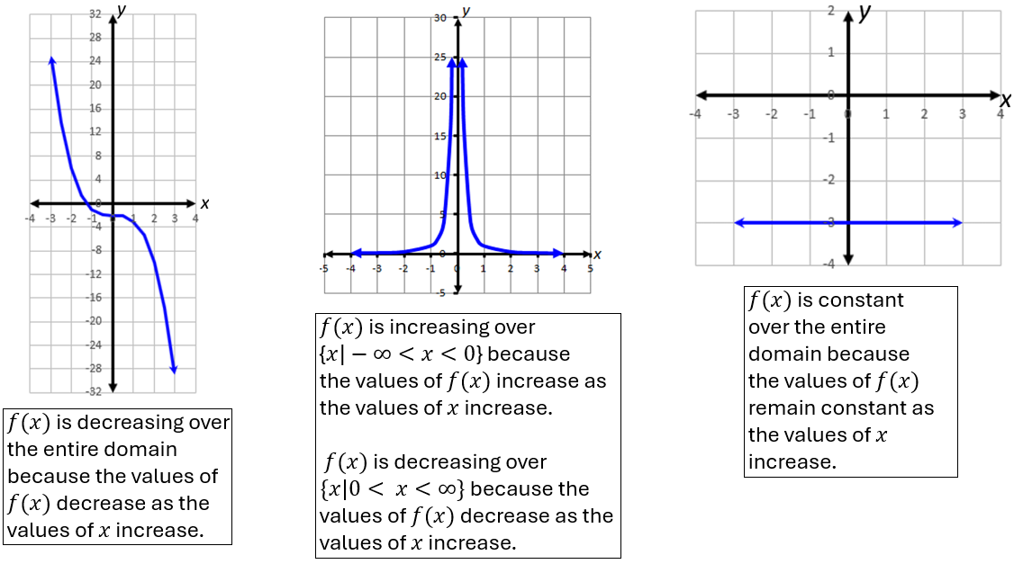

* Solutions and intervals may be expressed in different formats, including equations and inequalities, set notation, or interval notation.
  + Set notation is used when explicitly identifying each element of the solution set. It is represented using braces around the solution set.
  + Interval notation is used when describing a range of values. It can be used to define solutions to inequalities. A bracket is used when the endpoint of the range is included (i.e., ). A parenthesis is used when the endpoint of the range is not included (i.e., ). Additionally, a parenthesis is always used with infinity and negative infinity (∞ and -∞, respectively).
* Examples may include:

|  |  |  |
| --- | --- | --- |
| **Equation/Inequality** | **Set Notation** | **Interval Notation** |
| $$x = 3$$ | $$\{3\}$$ |  |
| $x = 3$ or |  |  |
|  |  |  |
|  | {} |  |
| Empty (null) set ∅ | { } |  |

* The term *extrema* (plural of *extremum)* refers to the maximum and minimum values of a function.
  + A function, *f*, has an absolute maximum located at *x* = *a* if *f(a)* is the largest value of *f* over its domain.
  + A function, *f*, has an absolute minimum located at *x* = *a* if *f(a)* is the smallest value of *f* over its domain.
  + Relative maximum points occur where the function changes from increasing to decreasing.
  + A function, *f*, has a relative maximum located at *x* = *a* over some open interval of the domain if *f(a)* is the largest value of *f* on the interval.
  + Relative minimum points occur where the function changes from decreasing to increasing.
  + A function, *f*, has a relative minimum located at *x* = *a* over some open interval of the domain if *f(a)* is the smallest value of *f* on the interval.
* The function $f\left(x\right)=x^{4}-2x^{2}+x$ is represented by the graph below. The relative minima, absolute minimum, and relative maximum are labeled. The function does not have an absolute maximum.

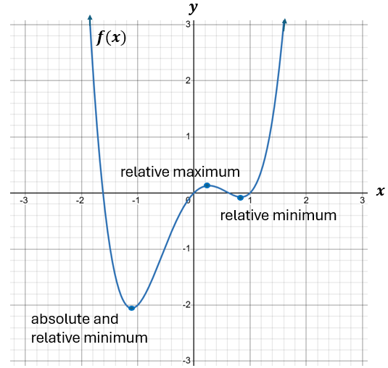

* The *x-*intercepts of a graph are located where the graph crosses the *x-*axis. A value *x* in the domain of *f* is an *x*-intercept or a zero of a function *f* if and only if *f(x)* = 0. See the example below.

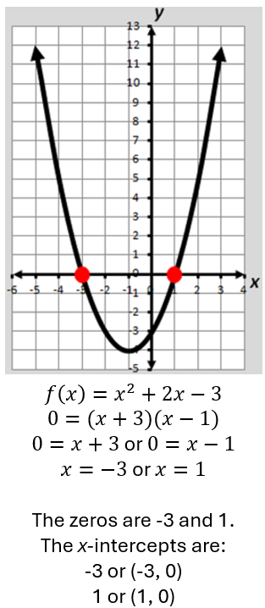

* End behavior shows what is happening at the ends of a graph and describes the values of a function as *x* approaches positive or negative infinity. See the examples below.

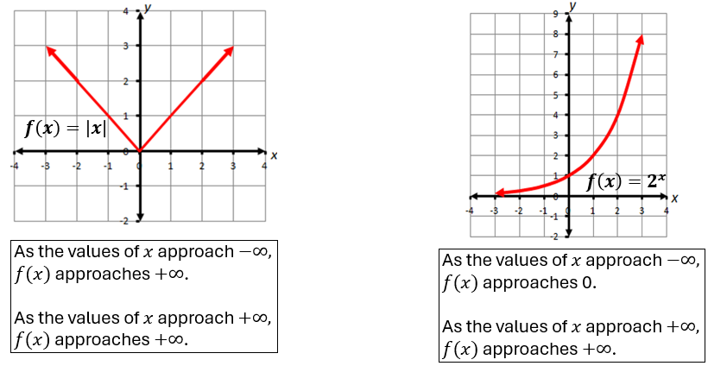

* The reflection of a function over the line $y=x$ represents the inverse of the reflected function.
* If (*a*, *b*) is an element of a function, then (*b*, *a*) is an element of the inverse of the function.
* A function is invertible if its inverse is also a function. For an inverse of a function to be a function, the domain of the function may need to be restricted. In the example below, $f\left(x\right)=\sqrt{x}$, and the domain is restricted to $x≥0.$ The inverse function is $f^{-1}\left(x\right)=x^{2},$ and the domain is restricted to $x≥0$.

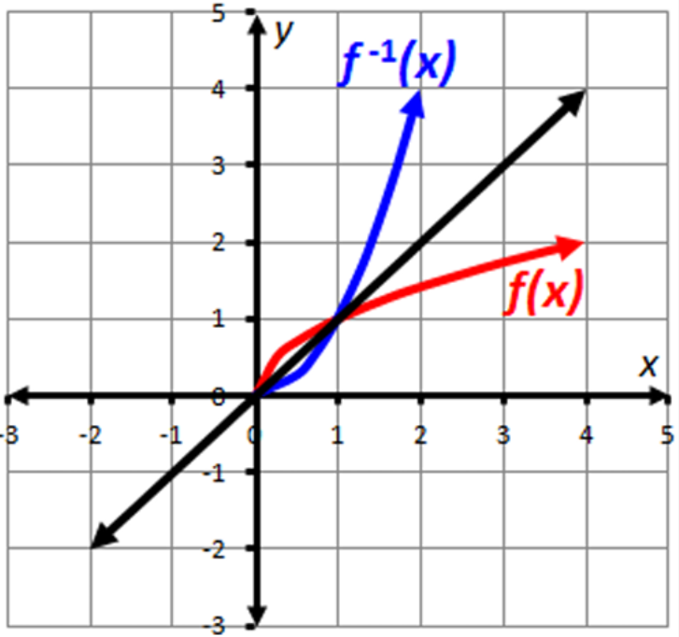

* Two functions, *f(x)* and *g(x)*, are inverse of each other if $f\left(g\left(x\right)\right)=g\left(f\left(x\right)\right)=x.$
* Functions can be combined using composition of functions. If there are two functions, *f(x)* and *g(x),* the composition of *f* and *g* is written as $\left(f∘g\right)\left(x\right)=f(g\left(x\right))$. This means you first apply $g$ to $x$, then apply $f$ to the result of $g\left(x\right).$ For example, if $f\left(x\right)=x^{2}$ and $g\left(x\right)=x+3,$ then $\left(f∘g\right)\left(x\right)=f\left(g\left(x\right)\right)=f\left(x+3\right)={(x+3)}^{2}.$
* For contextual situations, exponential functions can be used to represent compound interest, population growth, and radioactive decay.
* Restrictions on the domain may need to be added to the function to appropriately represent the contextual situation.

###### Skills in Practice

While the five process goals are expected to be embedded in each standard, the Skills in Practice highlight the most prevalent process goals in relation to the content presented.

**Mathematical Problem Solving**

* Students may demonstrate several common errors as they develop their understanding of functions and inverse functions.
  + When given $f\left(x\right)={(x-2)}^{2}$ and asked to find $f^{-1}\left(x\right)$, a common error is for students to state that $f^{-1}(x)=\sqrt{x+2},$ instead of the correct inverse function $f^{-1}\left(x\right)=\sqrt{x}+2$. This may indicate that a student has a misunderstanding of the order of using inverse operations to solve an equation for a specific variable. Additionally, if asked to find the value of $f^{-1}(f\left(5\right))$, students may respond with an incorrect answer of 49. This response likely resulted from students determining that $f\left(5\right)={\left(5-2\right)}^{2}=9$, and then determining that $f^{-1}\left(9\right)={\left(9-2\right)}^{2}=49$. This may indicate that students believe that $f(x)$ and $f^{-1}(x)$ are one and the same. To address both misconceptions, teachers may wish to have students create a table of values for the function *f(x)*. Discuss with students that a point on *f* is represented by the ordered pair (*x, y),* and a point on $f^{-1}$ is represented by (*y, x*). Creating a graph from the ordered pairs will help students visualize the reflection of these functions over the line *y = x* and understand how they are distinct functions. Seeing the graph will also help students think about the equation of the function and how the order of the operations impacts the transformation.
  + When given a graph of a function, students should be able to graph the inverse of the function. Consider the function, $f\left(x\right)=\sqrt{x-1}+2$, which is modeled below.

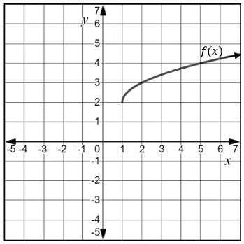

A common error that some students may make when graphing the inverse of the function is to graph $f^{-1}\left(x\right)=-\sqrt{x-1}-2.$ This may indicate a misunderstanding that the inverse function is the same as making the function negative. Some students may benefit from creating a table of values of the original function. Using this table of values, students may then create a table of values for the inverse function. The students should graph the points, then model the line *y = x* to see whether the original function and the inverse function are mirror images. This would verify that their graphs are correct.

* Students may have difficulty determining the composition of two functions algebraically and graphically.
  + For example, given $f\left(x\right)=3x^{2}-12 and g\left(x\right)=2x+1$, students may be asked to find $g(f\left(x\right))$. A common error is for students to solve $f\left(g\left(x\right)\right)$ instead, which would result in the following: $f(g\left(x\right))=3{(2x+1)}^{2}-12=3\left(4x^{2}+4x+1\right)-12=12x^{2}+12x-9.$ This may indicate that the student does not understand that composition is not a commutative operation and that finding *f(g(x))* does not produce the same result as finding *g(f(x))*. Solving $g(f\left(x\right))$ should result in the following computation: $g\left(f\left(x\right)\right)=2\left(3x^{2}-12\right)+1=6x^{2}-24+1={6x}^{2}-23$. The teacher may wish to have students create a mapping of the process *x* 🡪*f* 🡪 *g*. This may help students visualize the proper order of evaluating. Teachers may also wish to have the students practice evaluating functions by using a given expression as the input value to help students understand the notation of compositions and its application.
  + Students may struggle to determine the composition of two functions when presented graphically. Consider the functions *f(x)* and *g(x)*, presented graphically below.

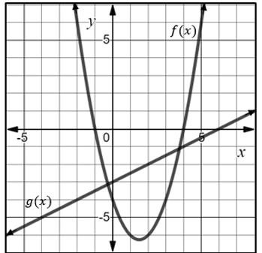

When asked to find $f(g(2))$, a common error is for students to say that $f(g(2))=-6$*,* rather than $f(g(2))=6$. This may indicate the student has a misconception in thinking that they need to evaluate the *f* function first, then the *g* function. The teacher may wish to have students think about the mapping process and how the 2 is the *x* value of the function *g.* Using colored pencils or highlighters to mark the *x* value and find the corresponding *y* value may be helpful for some students.

**Mathematical Representations:**

* Students should have opportunities to determine absolute and relative minima and maxima of a function presented graphically and algebraically. For example, consider the graph below.

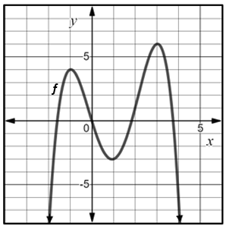

* + When asked to determine the value of the relative minimum of function *f* on the interval (0, 2), students may incorrectly provide a value of 1, instead of a correct value of -3. This may indicate that students have a misunderstanding that the value of the relative minimum is the *x-*value, rather than the y-value, of the point where the function changes from decreasing to increasing. Students may benefit from finding the values in an input/output table. When finding the “value” of a function at a certain point, students are substituting the *x-*value to find the corresponding *y-*value. When working with a graphical representation, it is the same concept, but students are looking at the graph for the *x-*coordinate and the corresponding *y-*value. Students may benefit from exposure to the different ways in which questions could be asked and to which values those questions are referring. Examples would include:
    - What is the value of the extrema? – This question refers to the *y-*values.
    - What is the interval where the extrema occur? – This question refers to *x*-values.
  + Students may also have difficulty determining whether a function has an absolute minimum, absolute maximum, both, or neither. In the graph above, a common error is for students to state the value of the absolute maximum is 4. While 4 represents the value of a relative maximum, it does not represent the highest point on the graph. Instead, the absolute maximum 6. Another common error is to state that the function has both an absolute maximum and an absolute minimum. Consider the end behavior of the function: as $x$ approaches $-∞$, $f(x)$ approaches $-∞$, and as $x$ approaches $∞,$ $f(x)$ approaches $-∞$. Thus, the function does not have an absolute minimum. These errors indicate that the students do not have a strong understanding of the difference between an absolute extrema and relative extrema of a function, or they may not recognize that functions that decrease without bound do not have an absolute minimum.
* Students should have opportunities to approximate the vertical and horizontal asymptotes of a function by sketching the asymptotes on a graph and labeling asymptotes. Consider the following function *g(x),* represented graphically below.

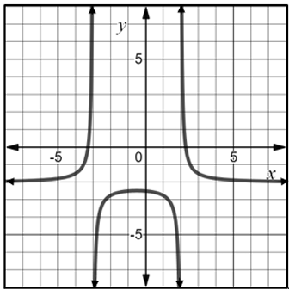

A common error is for students to confuse horizontal and vertical asymptotes and incorrectly state that the horizontal asymptotes appear to be *x* = -3 and *x* = 2 and the vertical asymptote appears to be *y* = -2. This may indicate a misunderstanding of which asymptotes are horizontal and which asymptotes are vertical. Other students may correctly identify the horizontal and vertical asymptotes but make an error when writing the equations of horizontal and vertical lines. For example, they may write y = -3 and y = 2 as the vertical asymptotes. Students who demonstrate these errors may need to review the difference between vertical and horizontal lines. Additionally, having students use technology, such as Desmos, to determine asymptotes when given the equation of a function, might help students discern the difference between horizontal and vertical asymptotes.

* Students should have opportunities to approximate the zeros of a function when presented graphically. Consider the example below.

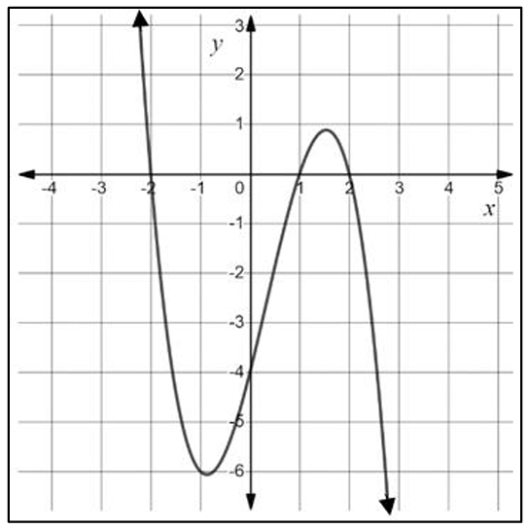

When asked to determine what appear to be the zeros of the function given the graph above, a common error is for students to include the *y*-intercept as a zero of the function (i.e., *y =* -4). This may indicate a misunderstanding that zeros are both *x-* and *y-*intercepts. Students who demonstrate this misunderstanding may benefit from creating a table of all the intercepts of the function. This table will show that *f(x)* = 0 only at values where the polynomial intercepts the *x-*axis.

**Mathematical Reasoning:**

* Students should have opportunities to determine the zeros of a function presented graphically and algebraically. As students become proficient with this skill, there are some common mistakes they may make.
  + One common error is to include the *y-*intercept as a zero of a function, which indicates that students misinterpreted the term “zero” to be a location anywhere the function crosses an axis. It would be helpful for students to highlight the *x-*intercepts and then express the values as *x-*intercepts, zeros, and roots/solutions.
  + Another common error when presented with a function such as $f\left(x\right)=\frac{(x+2)(x-3)(2x+5)}{(x+4)(x-1)}$ is for students to list the zeros of this function as -3, 2, and $\frac{5}{2}$. This may indicate that students are approaching this algebraically but did not set the expressions $x+2, x-3, and 2x+5$ to equal zero to find the zeros of this function. Additionally, some students may have solved for the zeros correctly, but also included -4 and +1 as zeros, which indicates that students have not made the connection that these values are undefined.
  + A third common error is for students to state that a function such as $f\left(x\right)=x^{2}+4x+5$ has no zeros. This indicates a misconception that because the roots are nonreal and the graph does not intersect the *x-*axis, there are no zeros. Students would benefit from a discussion on how zeros are the roots or solutions of the equation. When they are real, the roots are located at the *x-*intercept. When the roots of a function are nonreal or complex, they exist, but the function does not cross or touch the *x*-axis. Students may benefit from substituting complex solutions into a quadratic equation to emphasize that they do still make the function equal to zero algebraically.
* Students should have opportunities to describe the end behavior of a function. As students develop their understanding of the end behavior of a function, they may demonstrate several misconceptions.
  + One common misconception is for students to believe that, for any function, as *x* approaches negative infinity, *f(x)* approaches negative infinity and similarly, as *x* approaches positive infinity, *f(x)* approaches positive infinity. Having students create a table of values and evaluate the given function at certain positions such as *x = 5, x = 50, x = 100,* and *x = 1000* will help students see the behavior of the function as *x* increases. Similarly, students could create a table of values and evaluate the given function as certain positions such as *x* = -5, *x* = -50, *x* = -100, and *x* = -1000 will help students see the behavior of the function as *x* decreases.
  + Similarly, some students believe that if a graph is decreasing, it must approach negative infinity. This may indicate a misunderstanding that the end behavior of a function only approaches positive or negative infinity. Yet, consider the graph of $f\left(x\right)=3{(\frac{1}{3})}^{x}$, modeled below. Students should understand that as the value of *x* increases, the function becomes closer and closer to 0.

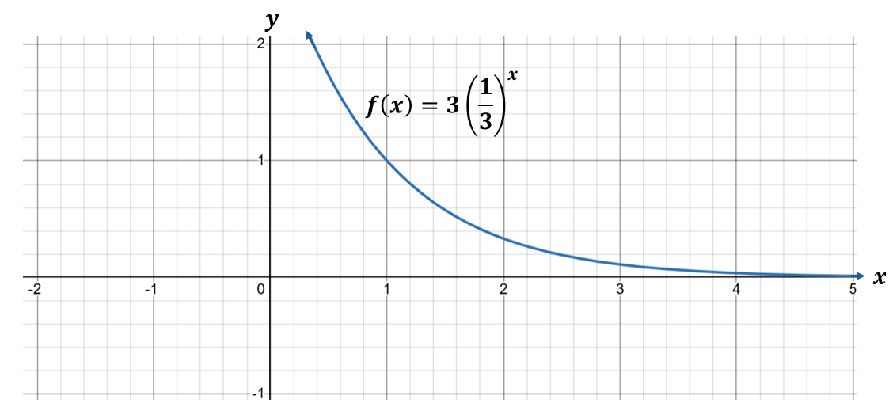

**Mathematical Connections:**

* Students may have difficulty when determining the domain and range of a function. Some common errors include identifying the domain as only the values between two *x*-intercepts or confusing the domain and range by listing the domain as the *y-*values and the range as the *x-*values. Students may struggle to correctly identify the range when there is a discontinuity (point or asymptote). Additionally, some students may recognize a domain includes a point of discontinuity but are unsure how to express the domain using interval notation. Listing additional pairs from a graph in a set or table may help students determine the difference between the domain and range of a function. Another strategy that can help solidify student understanding is a matching activity where students match the equation, graph, domain, and range. Graphing using technology, such as Desmos, can also help students visually see the domain, range, and discontinuities of a function. However, students should be cautioned when graphing a function such as $\frac{(2x^{3}+5x^{2}-12x}{x+4}$. While the function appears to be continuous when graphed in Desmos, there is a point of discontinuity at *x =* -4. (This is evident when hovering over the graph at *x =* -4.)Students would benefit from a discussion of what happens to values of *x* when *x* appears in the denominator of a function.
* Students may struggle to determine *f(x)* when given *x.* 
  + For example, when given a function such as $h\left(x\right)=\frac{2}{x-3}+4$ and asked to determine the value of $h(6)$*,* students may incorrectly replace *h(x)* with the value of 6, resulting in an inaccurate equation: $6=\frac{2}{x-3}+4$. This may indicate that some students think 6 is the value of *h(x)* instead of the value of *x*. Students should be encouraged to rewrite the function as $h\left(6\right)=\frac{2}{6-3}+4$, and then evaluate the right side of the equation.
  + Use the graph of $k(x)$ below when considering the following two questions:
    - What is the approximate value of $k(0)$?
    - Determine all the values that appear to be positive: $k\left(-4\right), k\left(-2\right), k\left(-1\right), k\left(2\right), k\left(5\right), k(6)$

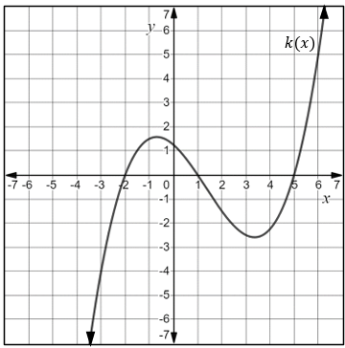

When responding to the first question, students may incorrectly state that *k(0)* = -2 or 1 or 5. This indicates that a student interprets finding the value of a function as finding the zero of the function when given the graph. Since *k(0)* means finding the value of the function when *x = 0,* a strategy is to have students draw a vertical line representing *x = 0* and determine the *y-*coordinate of the point where the vertical line intersects the graph of the function provided.

When responding to the second question, a common error is for students to choose all function values that contain a positive value, representing *x* when written in *k(x)* format (i.e., *k(2), k(5),* and *k(6))*. This may indicate that students are not basing their decision on a location of the graph of *k(x)* and whether its range value is greater than zero. A strategy that may be helpful is to have students trace the portions of the curve that are above the *x-*axis using a colored pencil or marker since the function is only positive in those locations. Students may then select all the function values provided that lie on the curve that has been color-coded.

###### Concepts and Connections

Concepts

Polynomial, exponential, logarithmic, piecewise-defined, radical, and rational functions are used to model everyday experiences.

Connections

* *Within the grade level/course:*
  + A2.F.1 – The student will investigate, analyze, and compare square root, cube root, rational, exponential, and logarithmic function families, algebraically and graphically, using transformations.
* *Vertical Progression*:
  + 8.PFA.2 – The student will determine whether a given relation is a function and determine the domain and range of a function.
  + A.F.1 – The student will investigate, analyze, and compare linear functions algebraically and graphically, and model linear relationships.
  + A.F.2 – The student will investigate, analyze, and compare characteristics of functions, including quadratic and exponential functions, and model quadratic and exponential relationships.

Across Content Areas

* *Digital Learning Integration*
* 9-12 CT.B. Students use appropriate technologies to collect, organize, interpret, and analyze data sets to predict outcomes, draw conclusions, solve problems, and make evidence-based decisions.

###### Resources to Support Local Curriculum

* A list of approved textbooks and instructional materials is posted on the VDOE [website](https://www.doe.virginia.gov/teaching-learning-assessment/k-12-standards-instruction/mathematics/2024-mathematics-textbooks).
* [EOC Algebra 2 Formula Sheet](https://www.doe.virginia.gov/home/showpublisheddocument/56035/638581953490870000)(PDF)
* [Table of Standard Normal Probabilities](https://www.doe.virginia.gov/home/showpublisheddocument/20152/638043600831870000) (*z*-table) (PDF)
* Inverse Functions Exemplar Mathematics Instructional Plan ([Word](https://www.doe.virginia.gov/home/showpublisheddocument/51913/638502328975730000) | [PDF](https://www.doe.virginia.gov/home/showpublisheddocument/51915/638502329314970000))

## Statistics

Statistics is a branch of mathematics that allows people to qualify and quantify data. Students use statistics to formulate questions and communicate results of data that has been collected and analyzed. These skills are used in almost every area of life, including sports, banking, medicine, agriculture, government, and education to name a few.

Throughout Algebra 2, students will apply the data cycle with a focus on representing bivariate data in scatterplots, tables, and ordered pairs. Students will also be exposed to univariate quantitative data represented by a normal curve. Additionally, students will use data to determine appropriate linear, quadratic, and exponential best-fit curves that model the data. Further, students will compute and distinguish between permutations and combinations.

### A2.ST.1

##### The student will apply the data cycle (formulate questions; collect or acquire data; organize and represent data; and analyze data and communicate results) with a focus on univariate quantitative data represented by a smooth curve, including a normal curve.

1. Students will demonstrate the following Knowledge and Skills:
2. Formulate investigative questions that require the collection or acquisition of a large set of univariate quantitative data or summary statistics of a large set of univariate quantitative data and investigate questions using a data cycle.
3. Collect or acquire univariate data through research, or using surveys, observations, scientific experiments, polls, or questionnaires.
4. Examine the shape of a data set (skewed versus symmetric) that can be represented by a histogram, and sketch a smooth curve to model the distribution.
5. Identify the properties of a normal distribution.
6. Describe and interpret a data distribution represented by a smooth curve by analyzing measures of center, measures of spread, and shape of the curve.
7. Calculate and interpret the *z-*score for a value in a data set.
8. Compare two data points from two different distributions using *z*-scores.
9. Determine the solution to problems involving the relationship of the mean, standard deviation, and *z*-score of a data set represented by a smooth or normal curve.
10. Apply the Empirical Rule to answer investigative questions.
11. Compare multiple data distributions using measures of center, measures of spread, and shape of the distributions.

###### Understanding the Standard

* Students should explore the entire data cycle with a question and set of data that has been collected or acquired. Student reflection should occur throughout the data cycle. The data cycle includes the following steps: formulating questions to be explored with data, collecting or acquiring data, organizing and representing data, and analyzing and communicating results.

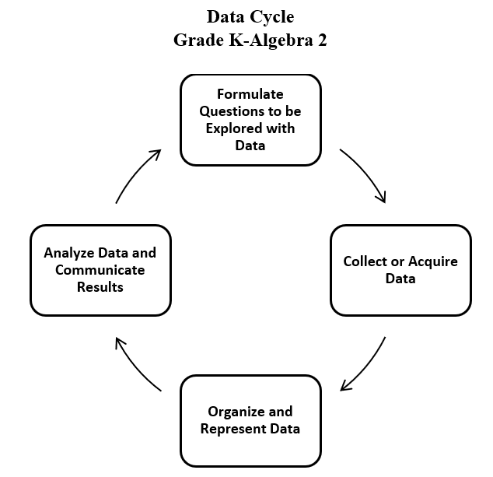

* Univariate quantitative data is numerical data that involves only one variable. Sample questions that would lead to the collection of univariate quantitative data include:
  + What are the heights of all seniors at Park High School?
  + How many banana splits were sold every day during the month of September at an ice-cream store?
  + What was the temperature in Richmond, Virginia every day during the month of May?
* One graphical representation of univariate data is a histogram. A histogram can be symmetric or skewed.
* In a symmetric histogram, the left and right sides are approximately mirror images of each other across a central vertical line. The bars rise to a central peak and then fall off in a similar way on both sides. This shape suggests that a data set is evenly spread around the center. In a perfectly symmetric distribution, the mean = median = mode, and all three are located at the center of distribution.

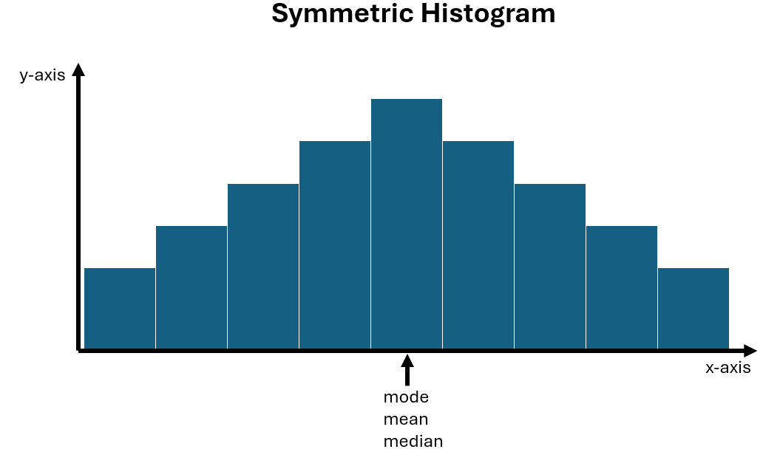

* In a skewed histogram, the histogram can be right-skewed or left-skewed.
* In a right-skewed histogram (also known as positively skewed), there is a long tail to the right (higher values) and most of the data are concentrated on the left (lower values). In a right-skewed histogram, the mean is pulled to the right (in the direction of the skew). Thus, the mean $>$ median $>$ mode.

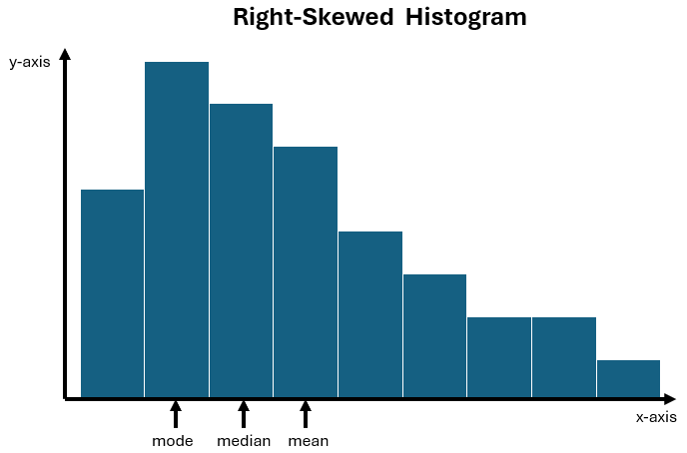

* In a left-skewed histogram (also known as negatively skewed), there is a long tail to the left (lower values) and most of the data are concentrated on the right (higher values). In a left-skewed histogram, the mean is pulled to the left (in the direction of the skew). Thus, the mean $<$ median $<$ mode.

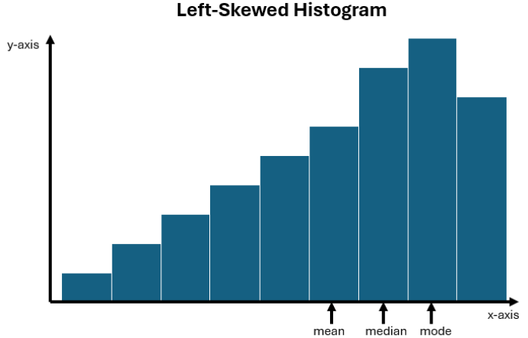

* A normal distribution curve is the family of symmetrical, bell-shaped curves defined by the mean and the standard deviation of a data set. The arithmetic mean (*μ*) is located on the line of symmetry of the curve and is approximately equivalent to the median and mode of the data set.
* The normal curve is a probability distribution and the total area under the curve is 1.
* For a normal distribution, approximately 68 percent of the data fall within one standard deviation of the mean, approximately 95 percent of the data fall within two standard deviations of the mean, and approximately 99.7 percent of the data fall within three standard deviations of the mean. This is often referred to as the Empirical Rule or the 68 – 95 – 99.7 rule.

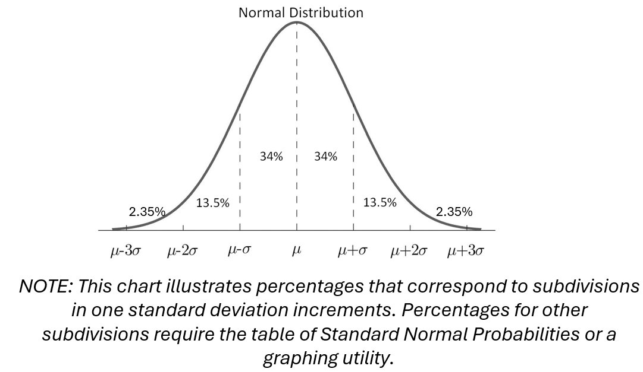

* Summary statistics include measures of center (mean, median, mode) and dispersion or spread (variance and standard deviation). These statistics can be used to approximate the shape of the distribution.
* Descriptive statistics include measures of center (mean, median, mode) and dispersion or spread (variance and standard deviation).
* The mean is a measure of central tendency and is the arithmetic average of a given data set. In Algebra 2, it is assumed that all data sets are population data sets. Population mean is represented by the symbol *μ* (mu) and is found by finding the sum of all data points and dividing by the number of data points. For example, given the data set 0, 2, 3, 7, 8, the mean can be calculated as: $μ=\frac{0+2+3+7+8}{5}=\frac{20}{5}=4.$
* The median is a measure of central tendency and is the middle value of a data set in ranked order. When given a data set with an odd number of data points, the median is the middle number. For example, given the data set 6, 7, 8, 9, 9, the median is 8. When given a data set with an even number of data points, the middle is the arithmetic average of the two middle data points. For example, given the data set 5, 6, 8, 9, 11, 12, the median is the average of 8 and 9, or 8.5.
* The mode is a measure of central tendency and is the data point that occurs most frequently. A set of data can have no mode, one mode, or multiple modes.
  + - Data set: 6, 7, 8, 9, 9; the mode is 9 (one mode)
    - Data set: 6, 8, 10, 11, 15, 20; there is no mode
    - Data set: 2, 2, 2, 3, 7, 9, 9, 9; the modes are 2 and 9 (multiple modes)
* Variance is a statistical measurement that describes the spread of numbers in a data set compared to the mean. Variance is represented by *σ* 2, which is the square of the standard deviation.
* Standard deviation (or SD) is a statistical measurement that describes the average difference between data points and the mean of the data set. Standard deviation is represented by the Greek letter sigma (*σ*) and can be calculated as the positive square root of the variance. It is expressed in the original units of measurement of the data.
* The greater the value of the standard deviation, the further the data tends to be dispersed from the mean (i.e., if the standard deviation is small, then the values of the data points tend to be close to the mean; if the standard deviation is large, then the values of the data points are more spread out (dispersed) and further from the mean).
* In order to develop an understanding of standard deviation as a measure of dispersion (spread), students should have experience analyzing the formulas for and the relationship between variance and standard deviation. The formulas are shown in the table below.

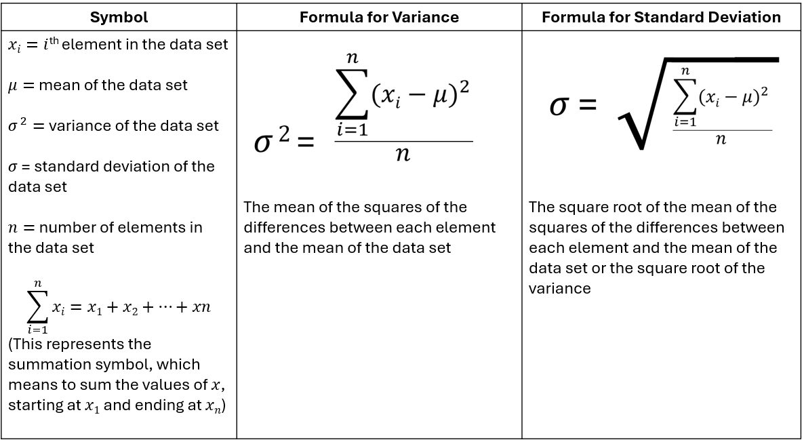

* The mean and standard deviation of a normal distribution affect the location and shape of the curve. The vertical line of symmetry of the normal distribution falls at the mean. The greater the standard deviation, the wider (“flatter” or “less peaked”) the distribution of the data.
* A *z*-score for an element in a data set is a number that tells how many standard deviations that specific element falls above or below the mean of the data set. It is positive if the data value lies above the mean and negative if the data value lies below the mean.
* The formula for calculating a *z*-score is $z=\frac{x-μ}{σ},$ where $x$ is the value of the data point, $μ$ is the mean of the distribution, and $σ$ is the standard deviation.

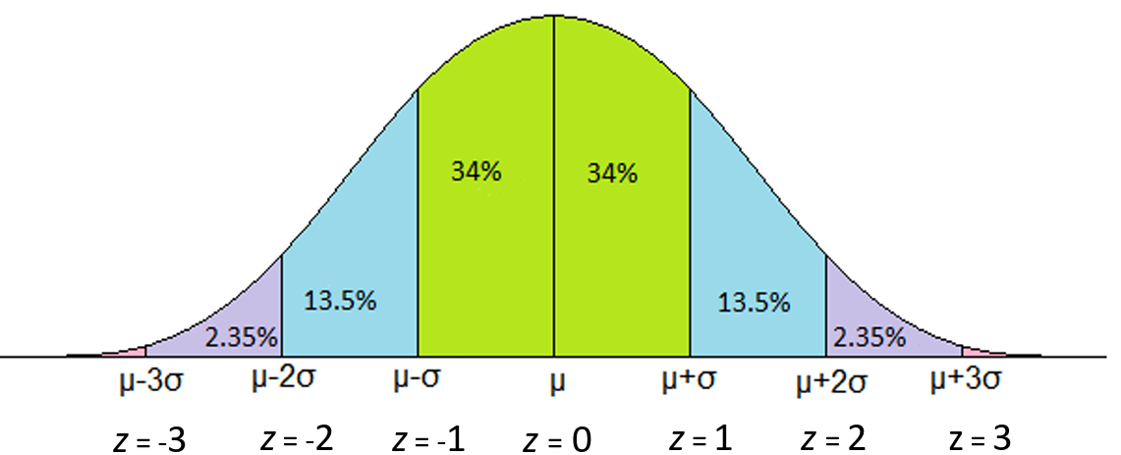

* *z-*scores are helpful because they allow comparisons between different values from different distributions. Additionally, they can be used to identify outliers (e.g., *z*-scores above +3 and below -3).
* A standard normal distribution is the set of all *z*-scores. The mean of the data in a standard normal distribution is 0 and the standard deviation is 1. This allows for the comparison of unlike normal data.
* Technology can be used to represent a normally distributed data set and explore relationships between the data set and its descriptive statistics.
* Students would benefit from exploring previously taught graphical representations when justifying how to best represent data clearly and accurately. Comparing different types of representations (charts and graphs) provides an opportunity to learn how different graphs can show different things about the same data. Discussions around what information different graphs representing the same data provide are beneficial for determining which graphical representation best represents the data.
* There are data sets that cannot be represented by a smooth or normal curve.

###### Skills in Practice

While the five process goals are expected to be embedded in each standard, the Skills in Practice highlight the most prevalent process goals in relation to the content presented.

**Mathematical Problem Solving**

* Students will benefit from exposure to contextual problems that require the application of a normal distribution. Consider the following scenario.

The weights of watermelons at a store are normally distributed. If 95% of the weights are centered between 10 and 18 pounds, what is the best estimate of the mean and standard deviation, in pounds, of this sample?

Students are often able to correctly state that the mean is 14 pounds. However, a common error is for students to state that the standard deviation is 4 pounds. This may indicate that a student believes the standard deviation is found by dividing the difference of the two stated values by 2 instead of 4 (to include 95% of the sample). A possible teaching strategy is to have students draw the normal distribution curve according to the information provided and label the mean and the values representing 1 SD and 2 SD from the mean.

* Students will benefit from exposure to contextual problems that require the comparison of *z*-scores. Consider the following scenario.

Among the students in a local school division, ACT scores were normally distributed this year with a mean score of 20.7 and a standard deviation of 5.9. SAT scores were normally distributed with a mean score of 1075 and a standard deviation of 168. Jamal took the ACT and scored a 29. Shamar took the SAT and scored a 1240. Who scored better on their standardized test with respect to the other test-takers in the school division?

A common error is for students to state that Shamar did better because he scored 165 points above the mean and Jamal only scored 8.3 points above the mean. This indicates that students did not normalize the test scores before comparing them, possibly because they did not recognize that a standard normal distribution is a set of *z-*scores of a data set and allows comparisons of unlike data. Instead, students should calculate a *z-*score for Jamal and Shamar. Doing so results in Jamal’s ACT score having a *z-*score of $≈1.41$ and Shamar’s SAT score having a *z-*score of $≈0.98$. Thus, with respect to other test-takers in the school division, Jamal scored better.

* Students will benefit from exposure to contextual problems that involve the area under the standard normal curve. Consider the following scenario.

Sam’s Pizza advertises that their delivery times are the best in town. If their delivery times are normally distributed with a mean of 30 minutes and a standard deviation of 5 minutes, what is the probability a pizza from Sam’s will take more than 37 minutes to be delivered?

A common error is for students to report the probability to the left of the *z-*score, either by using the Table of Standard Normal Probabilities or technology. This may indicate that students do not recognize that the area under the normal curve to the right of the *z-*score will represent the probability that the pizza will take more than 37 minutes to be delivered. A potential teaching strategy could include requiring students to sketch the normal curve with the area in question shaded and then asking students to make predictions of reasonable values prior to using the table.

**Mathematical Representations:** Students should be able to identify different representations of normal distributions, and they should be familiar with characteristics of normal distributions. Consider the following representations:

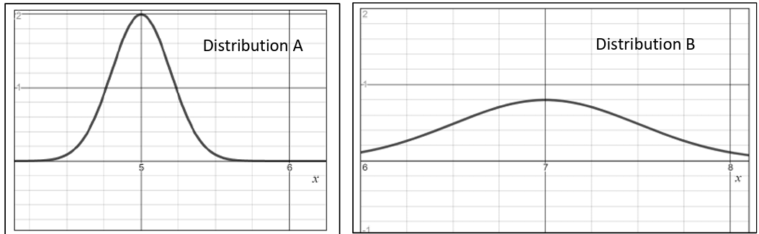

When comparing Distribution A and Distribution B, a common error that some students may make is to choose Distribution A as having the larger mean. This may indicate that students interpreted the curve that appears to be taller as having a larger mean because they interpreted the vertical height at the top of the curve as the mean. Similarly, students may incorrectly state that Distribution A has a greater standard deviation than Distribution B. This may indicate that students do not recognize that the standard deviation is a measure of the spread and the greater the standard deviation, the wider the distribution of data. A potential teaching strategy may be to have students explore how changing the parameters of the normal distribution affect the curve using technology, such as Desmos (using the distribution function) to graph the two distributions on the same axes.

**Mathematical Communication:** There are many good questions students can ask about univariate data and bivariate data. With univariate data, information is gathered around a single characteristic (e.g., scores on assessments, time spent looking at social media, hours spent on an activity). In Algebra 2, this data should be limited to continuous data so that the data can be appropriately modeled, as opposed to approximated, by a smooth curve.

* What type of data can be collected for this question?
* Does the data I would collect make sense as either a histogram that can be modeled with a smooth curve (A2.ST.1) or a scatterplot (A2.ST.2)?
* Does the data allow for larger trend analysis?
* Does the available data reflect a representative sample of the population?
* Students should ask questions where they consider the overall pattern or trend of a single variable (univariate data) or the relationship between two variables (bivariate data).
* Examples of questions students may consider for histograms to smooth curves are –
  + Is the goal to determine the overall distribution of this variable?
  + Is the goal to determine the spread of this variable?
  + Is the goal to make comparisons between values of the variable?
  + Are the values of the variable normally distributed?
* The data sources must be considered as questions are formulated. Some questions that will direct students toward appropriate data sets include:
  + What is the context of the data to be collected?
  + What data is readily available?
  + What is the population of interest?
  + Who is the audience?
* Bias should be considered when analyzing data and reflecting upon results. Students should consider the validity of the data set; the intention of the data collection and proving a specific point; data cleaning; and patterns to any of the data that needed to be cleaned.
* As students analyze data and reflect upon their results, they should determine if there is a pattern to the data displayed. Further, students should consider the shape of the data and the curve(s) that could be used to model the data. Students must return to the question to see if their data answer the question and if not, begin the data cycle again. While doing so, students must determine how bias or sample size impacts the data and the representation.

###### Concepts and Connections

Concepts

Real-life contextual situations can be modeled by data. Normally distributed data can be investigated through generally accepted patterns, including the Empirical rule.

Connections

* *Within the grade level/course*:
  + A2.ST.3 – The student will compute and distinguish between permutations and combinations.
* *Vertical Progression*:
  + 8.PS.1 – The student will use statistical investigation to determine the probability of independent and dependent events, including those in context.

###### Resources to Support Local Curriculum

* A list of approved textbooks and instructional materials is posted on the VDOE [website](https://www.doe.virginia.gov/teaching-learning-assessment/k-12-standards-instruction/mathematics/2024-mathematics-textbooks).
* [EOC Algebra 2 Formula Sheet](https://www.doe.virginia.gov/home/showpublisheddocument/56035/638581953490870000)(PDF)
* [Table of Standard Normal Probabilities](https://www.doe.virginia.gov/home/showpublisheddocument/20152/638043600831870000) (*z*-table) (PDF)

### A2.ST.2

##### The student will apply the data cycle (formulate questions; collect or acquire data; organize and represent data; and analyze data and communicate results) with a focus on representing bivariate data in scatterplots and determining the curve of best fit using linear, quadratic, exponential, or a combination of these functions.

1. Students will demonstrate the following Knowledge and Skills:
2. Formulate investigative questions that require the collection or acquisition of bivariate data and investigate questions using a data cycle.
3. Collect or acquire bivariate data through research, or using surveys, observations, scientific experiments, polls, or questionnaires.
4. Represent bivariate data with a scatterplot using technology.
5. Determine whether the relationship between two quantitative variables is best approximated by a linear, quadratic, exponential, or a combination of these functions.
6. Determine the equation(s) of the function(s) that best models the relationship between two variables using technology. Curves of best fit may include a combination of linear, quadratic, or exponential (piecewise-defined) functions.
7. Use the correlation coefficient to designate the goodness of fit of a linear function using technology.
8. Make predictions, decisions, and critical judgments using data, scatterplots, or the equation(s) of the mathematical model.
9. Evaluate the reasonableness of a mathematical model of a contextual situation.

###### Understanding the Standard

* Students should explore the entire data cycle with a question and set of data that has been collected or acquired. Student reflection should occur throughout the data cycle. The data cycle includes the following steps: formulating questions to be explored with data, collecting or acquiring data, organizing and representing data, and analyzing and communicating results.



* Data and scatterplots may indicate patterns that can be represented with an algebraic equation.
* Determining the curve of best fit for a relationship among a set of data points is a tool for the algebraic analysis of data. In Algebra 2, curves of best fit may include linear, quadratic, exponential (piecewise-defined) functions, or a combination of these functions.
* By examining patterns in data (shape) given different representations like a table or scatterplot, specific bivariate relationships can be determined.
* Bivariate data is data that is collected from two different variables and compared against each other. The purpose of collecting bivariate data is to determine whether two variables are related or correlated.
* Two variables can be positively correlated, negatively correlated, or have no correlation. If two variables are positively correlated, then in general, the dependent $(y)$ values increase as the independent $(x)$ values increase. If two variables are negatively correlated, then in general, the dependent $(y)$ values decrease as the independent $(x)$ values increase. If two variables have no correlation, then there is no relationship between the dependent $(y)$ values and independent $(x)$ values.

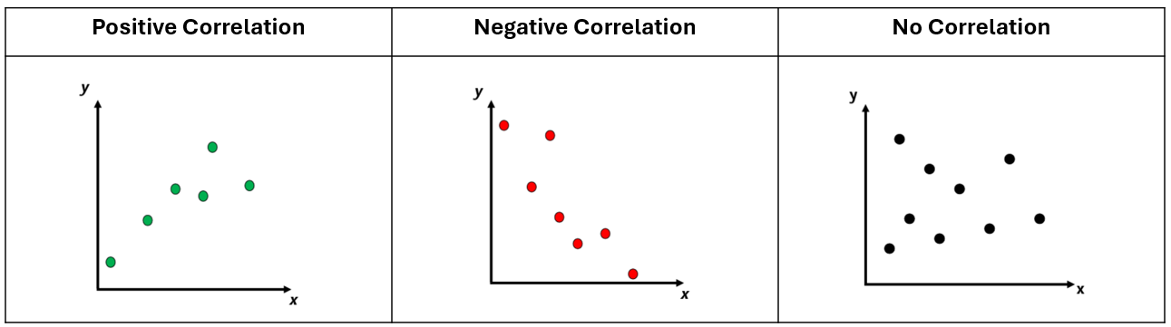

* Knowledge of transformational graphing using parent functions can be used to verify a mathematical model from a scatterplot that approximates the data.
* Categorical variables can be added to a scatterplot using color or different symbols.
* Technology can be used to collect, organize, represent, and generate an equation of a curve of best fit for a set of data.
* A set of data may include one or more outliers. An outlier is a data point that is significantly different from the rest of the data. It stands out because it is much higher or much lower than most other values in the data set. Outliers can affect the measures of central tendency, especially the mean.
* The Pearson correlation coefficient, *r*, is used to describe the strength and direction of a linear relationship between two variables. The correlation coefficient is a numerical value that ranges from -1 to +1. Numbers closer to -1 and +1 indicate stronger relationships; numbers close to 0 indicate weaker relationships. It is important to note that correlation does not imply causation. See the examples below.

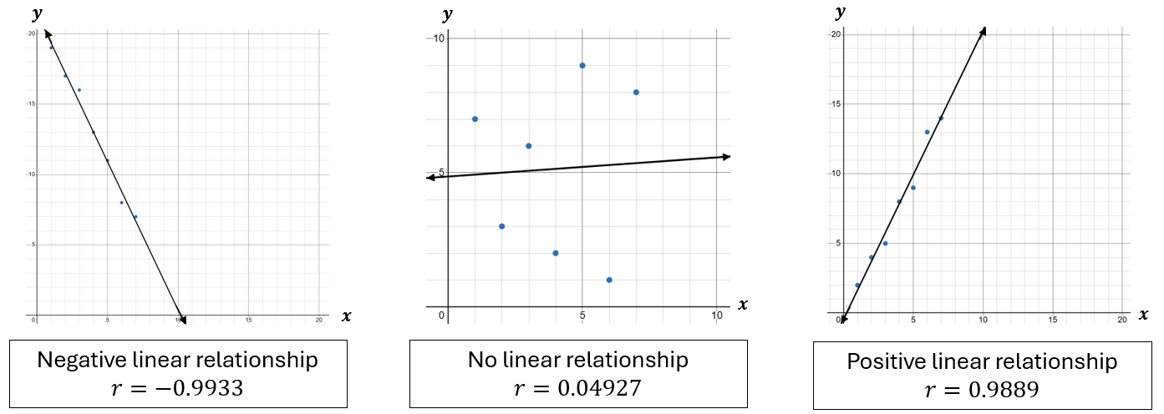

* The Pearson correlation coefficient, *r*, is used to identify patterns in linear relationships whereas the coefficient of determination, *R*2, is used to identify the strength of a model. However, there can be limitations since a high *R*2 does not necessarily indicate a good model. It is important to consider other factors such as assumptions about the model and deeper analysis (e.g., residual) that may go beyond the scope of Algebra 2.
* The mathematical model of the relationship among a set of data points can be used to make predictions, decisions, and critical judgments where appropriate.
* Interpolation is a method of estimating values within a set of data points based on the known values of the surrounding points. In other words, it involves using the data points that are available to make an educated guess about the value of a data point that is not explicitly given.
* Extrapolation is the process of estimating values outside the range of known data by extending a curve or trend line beyond the observed data points. In other words, it involves making predictions about values that are outside the range of the available data based on the assumption that the same trend will continue beyond the observed data.
* The validity of predictions decreases as the degree of extrapolation increases.
* Technology can be used to collect, organize, represent, and generate an equation of a curve of best fit for a set of data.
* Data that fit linear ($y=ax+b$), quadratic ($y={ax}^{2}+bx+c$), and exponential ($y={ab}^{x}$) models arise from contextual situations.

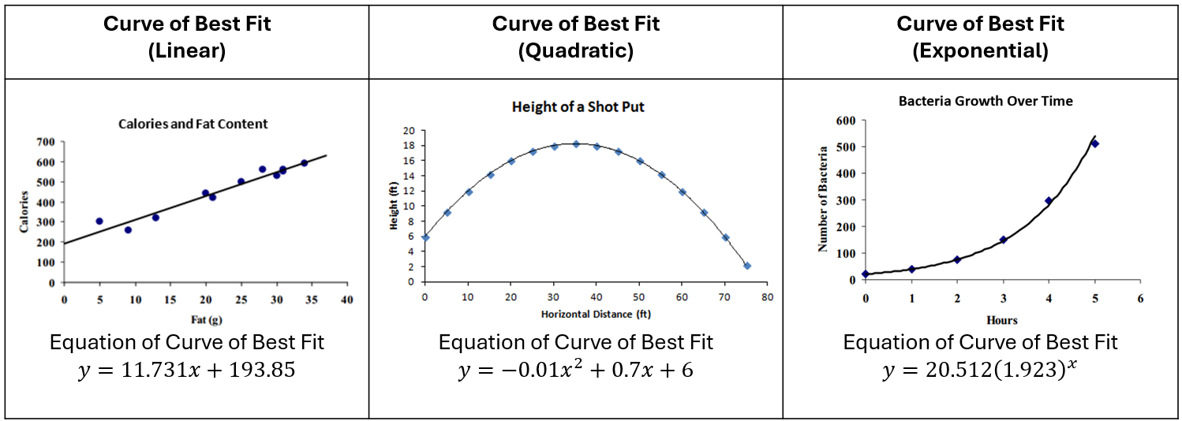

* The curve of best fit for the relationship among a set of data points can be used to make predictions where appropriate.
* Rounding that occurs during intermediate steps of problem solving may reduce the accuracy of the final answer.
* Evaluation of the reasonableness of a mathematical model of a contextual situation involves asking questions including:
  + Is there another curve (quadratic or exponential) that better fits the data?
  + Does the curve of best fit make sense?
  + Could the curve of best fit be used to make reasonable predictions?
  + Is some subset of the data better represented by a different function?
  + For what values of the domain is the model appropriate?
* Students would benefit from exploring previously taught graphical representations when justifying how to best represent data clearly and accurately. Comparing different types of representations (charts and graphs) provides an opportunity to learn how different graphs can show different things about the same data. Discussions around what information different graphs representing the same data provide are beneficial for determining which graphical representation best represents the data.

###### Skills in Practice

While the five process goals are expected to be embedded in each standard, the Skills in Practice highlight the most prevalent process goals in relation to the content presented.

* **Mathematical Communication:** Numerical data represented by two variables (e.g., time and distance, age and height) are bivariate data. There are many good questions students can ask about bivariate data. Examples of questions that could include the collection of bivariate data include:
  + Do students who study more perform better on exams?
    - Defined variables: hours studied (independent), exam scores (dependent)
  + Is there a correlation between temperature and ice cream sales?
    - Defined variables: temperature (independent), ice cream sales (dependent)
  + Is there a connection between age and amount of daily screen time?
    - Defined variables: age (independent), amount of daily screen time (dependent)

* Students should ask questions that involve the relationship between two characteristics or variables; they are looking for trends in this relationship or looking to make a prediction based on the relationship.
* Students should have opportunities to explore the shape of the data in a scatterplot. Is it linear or is it nonlinear? Does it have a quadratic relationship? Does it have an exponential relationship?
* Students should explore the concept of curve of best fit. How does the shape of the scatterplot determine what type of curve should be applied?
* The labels are key to communication; what title and labels are necessary to clearly communicate? Should a curve of best fit be drawn to model the data?
* Examples of questions students may consider when building good samples include:
  + What is the context of the data to be collected?
  + Who is the audience?
  + What is an appropriate amount of data?

**Mathematical Reasoning:** As students analyze data and reflect upon their results, they should determine if there is a pattern to the data displayed. The relationship could be linear, quadratic, exponential, or a combination of these. Further, students should consider the shape of the data and determine if a specific linear, quadratic, or exponential model fits the data. Students must return to the question to see if their data answers the question and if not, begin the data cycle again. While doing so, students must determine how bias or sample size impacts the data and the representation.

* Scatterplots show the relationship between two variables. Considerations for scatterplots include –
  + Is the goal to determine the potential relationship between these two variables?
  + Is there a correlation between the variables? If so, what type of correlation?
  + Is it important to see individual data points?
  + Is the goal to make predictions about these variables?
  + Does a line (or curve) of best fit help to make predictions about this data?
* As students explore the data displays, they should be looking for patterns that are evident in the shape of the data. Students should ask if the display appears linear or nonlinear. If the display appears nonlinear, is there a quadratic relationship? Exponential relationship?
* In Algebra 2, students recognize that for many data sets, the relationship between two variables does not follow the same consistent pattern for all values in the domain. For example, a person’s height does not increase at the same relationship with their age over the course of their lifetime.

**Mathematical Representations:** Students should have opportunities to graph a set of data and determine a model that might best fit a set of data. Consider the scenarios below.

Scenario 1: The chart below shows the profits earned per week by a business during the first 7 weeks after opening. Write a regression equation to model the situation and explain why you chose this model.

|  |  |  |  |  |  |  |  |
| --- | --- | --- | --- | --- | --- | --- | --- |
| Week | 1 | 2 | 3 | 4 | 5 | 6 | 7 |
| Profit (in thousands of dollars) | 4.1 | 0.8 | 0 | 1.1 | 5 | 8.5 | 16.7 |

Scenario 2: The table below shows the U.S. population (measured in millions) for various years since 1800. Would this data best be represented by a linear model or an exponential model?

|  |  |  |  |  |  |  |  |
| --- | --- | --- | --- | --- | --- | --- | --- |
| Years since 1800 | 0 | 10 | 20 | 30 | 40 | 50 | 60 |
| Population (in millions) | 5.31 | 7.24 | 9.64 | 12.87 | 17.07 | 23.19 | 31.44 |

A common error is for students to assume that both scenarios are best represented by a linear model. In Scenario 1, students may try to calculate a line of best fit. This may indicate that students incorrectly assume that profits would increase at a constant rate and would follow a linear model. In Scenario 2, students may incorrectly believe the data pattern is linear because the independent values are increasing at a constant rate. This could indicate that students do not understand that the changes in both the independent and dependent values must be considered when determining a model that might best fit a set of data. A potential teaching strategy is to have students use technology to graph the data points and have students determine what parent function best models the graph. Once they have done this, they can then sketch a curve that they feel best fits the data and calculate the actual equation to check the fit.

###### Concepts and Connections

Concepts

Real-life contextual situations can be modeled by data. Data allows us to make decisions.

Connections

* *Within the grade level/course*:
  + A2.F.2 – The student will investigate and analyze characteristics of square root, cube root, rational, polynomial, exponential, logarithmic, and piecewise-defined functions algebraically and graphically.
* *Vertical Progression*:
  + A.F.1 – The student will investigate, analyze, and compare linear functions algebraically and graphically, and model linear relationships.
  + A.F.2 – The student will investigate, analyze, and compare characteristics of functions, including quadratic and exponential functions, and model quadratic and exponential relationships.
  + A.ST.1 – The student will apply the data cycle (formulate questions; collect or acquire data; organize and represent data; and analyze data and communicate results) with a focus on representing bivariate data in scatterplots and determining the curve of best fit using linear and quadratic functions.

Across Content Areas

* *Digital Learning Integration*
* 9-12 CT.A. Students demonstrate how to identify, explore, and solve a real-world problem using technology-assisted methods such as data analysis, modeling, or algorithmic thinking.
* 9-12 CT.B. Students use appropriate technologies to collect, organize, interpret, and analyze data sets to predict outcomes, draw conclusions, solve problems, and make evidence-based decisions.

###### Resources to Support Local Curriculum

* A list of approved textbooks and instructional materials is posted on the VDOE [website](https://www.doe.virginia.gov/teaching-learning-assessment/k-12-standards-instruction/mathematics/2024-mathematics-textbooks).
* [EOC Algebra 2 Formula Sheet](https://www.doe.virginia.gov/home/showpublisheddocument/56035/638581953490870000)(PDF)
* [Table of Standard Normal Probabilities](https://www.doe.virginia.gov/home/showpublisheddocument/20152/638043600831870000) (*z*-table) (PDF)

### A2.ST.3

##### The student will compute and distinguish between permutations and combinations.

1. Students will demonstrate the following Knowledge and Skills:
2. Compare and contrast permutations and combinations to count the number of ways that events can occur.
3. Calculate the number of permutations of *n* objects taken *r* at a time.
4. Calculate the number of combinations of *n* objects taken *r* at a time.
5. Use permutations and combinations as counting techniques to solve contextual problems.
6. Calculate and verify permutations and combinations using technology.

###### Understanding the Standard

* The *Fundamental Counting Principle* states that if there are *m* ways for one event to occur and *n* ways for a second event to occur, then there are *m $∙$ n* ways for both events to occur. For example, how many outfits can be made using 3 pairs of pants and 4 shirts? There can be 12 outfits (3 $∙$ 4 = 12).
* Permutations and combinations are methods of ordering objects.
* The formulas for determining the number of permutations and combinations require an understanding of factorials. The factorial of a whole number, *n*, is the product of all positive integers from 1 to *n*. For example, the factorial of $6=6∙5∙4∙3∙2∙1=720$. This can also be written as 6!
* A permutation is the number of possible ways to arrange a group of objects without repetition and when order matters (e.g., the outcome 1, 2, 3 is different from the outcome 3, 2, 1 when order matters; therefore, both arrangements would be included in the possible outcomes).
* In a permutation, 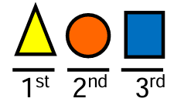 is considered different than 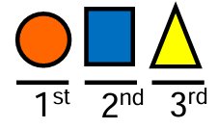. Thus, both arrangements are included in possible outcomes. Other examples of situations that require permutations include the order of 5 people sitting in chairs; the order of finishing first, second and third in a race; or the order of results from a vote (first choice, second choice, third choice).
* The formula for calculating the number of permutations is listed below.

*nr* , where $n$ and $r$ are positive integers, $n≥r,$ and $n$ is the total number of elements in the set and $r$ is the number to be ordered.

* A combination is the number of possible ways to select or arrange objects without repetition and when order does not matter (e.g., the outcome 1, 2, 3 is the same as the outcome 3, 2, 1 when order does not matter; therefore, both arrangements would not be included in the possible outcomes).
* In a combination, 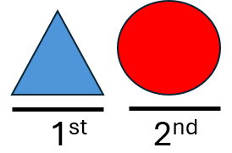 is considered the same as 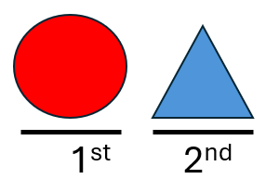. This combination is only counted once in the total outcomes. Other examples of situations that require combinations include choosing a committee without assigning roles, drawing a 5-card hand from a deck of cards, selecting 2 desserts from a menu of 6 desserts.
* The formula for calculating the number of combinations is listed below.

*nr* , where $n$ and $r$ are positive integers, $n≥r$, and $n$ is the total number of elements in the set and $r$ is the number to be ordered.

###### Skills in Practice

While the five process goals are expected to be embedded in each standard, the Skills in Practice highlight the most prevalent process goals in relation to the content presented.

**Mathematical Communication:** Students may benefit from additional practice identifying scenarios that represent a permutation versus a combination. Additionally, students will benefit from practice that requires them to identify outcomes using different terminology. Consider the two scenarios below.

1. Westfield High School is having a contest and needs a team with 5 students from Mr. Chapman’s class. There are 20 students in Mr. Chapman’s class. How many different teams can be formed?
2. Eleven runners will compete in a race. Trophies will be awarded to the first- and second-place finishers. How many ways can the runners finish in first and second place?

Students may have difficulty distinguishing between a scenario that represents a permutation and a scenario that represents a combination. For example, students may incorrectly identify scenario a) as a permutation because they see the word “different” and assume the scenario represents a permutation. Similarly, students may incorrectly identify scenario b) as a combination because they do not understand that the order of the runners finishing the race matters.

Students who demonstrate these misconceptions would benefit from a discussion on events or circumstances when order matters. When providing instruction about permutations, encourage students to compile a list of situations where the order of events matter. When providing instruction about combinations, reiterate the idea that every object selected from the whole group has equal value/importance (e.g., same job, same title). A teaching strategy that may benefit students is to provide a visual representation of combinations and permutations. Have three student volunteers stand in a row at the front of the classroom. Ask questions like -- *How many groups of students are standing in front of the class?* *If the students rearrange themselves in a different order, does this change the number of groups of students standing in front of the class? If we were creating a three-person student council, and the first person called to the front of the room had a specific job (e.g., president), and each succeeding student held a different job (e.g., vice president, treasurer), would the order in which they were called affect the outcome of the student council?*

**Mathematical Problem Solving:** Students will benefit from additional practice solving contextual situations with permutations or combinations. Consider the following scenario.

There are 14 members of the scholastic bowl team, 8 of whom are boys and 6 of whom are girls. The coach wants to play 3 boys and 1 girl in the next round. How many different teams of 3 boys and 1 girl could be formed to play the next round?

Students may have difficulty applying the formula for combinations correctly. For example, students may incorrectly indicate there are 62 different teams. This error suggests that students understand the scenario represents a combination, but they incorrectly applied the Fundamental Counting Principle by adding the results instead of multiplying. Other students may incorrectly indicate there are 1001 different teams. This error suggests students understood the need to take 4 objects from 14 total objects, but they missed that there are specific details about who can be selected and did not correctly identify the values that should be used for $n$ *and $r.$* Discuss if 4 members were selected from the whole group of 14, they could all be boys. Instead, students should understand that to determine how many teams could be formed, they need to determine the combination for the boys (choosing 3 from 8, resulting in 56), and the combination from the girls (choosing one from six, resulting in 6), and multiply the results, leading to a final answer of 336 possible team formations.

###### Concepts and Connections

Concepts

Real-life contextual situations can be modeled by data. The world can be investigated through posing questions and collecting, representing, analyzing, and interpreting data to describe and predict events and real-world phenomena.

Connections

* *Within the grade level/course*:
  + A2.ST.1 – The student will apply the data cycle (formulate questions; collect or acquire data; organize and represent data; and analyze data and communicate results) with a focus on univariate quantitative data represented by a smooth curve, including a normal curve.
* *Vertical Progression*:
  + 8.PS.1 – The student will use statistical investigation to determine the probability of independent and dependent events, including those in context.

###### Resources to Support Local Curriculum

* A list of approved textbooks and instructional materials is posted on the VDOE [website](https://www.doe.virginia.gov/teaching-learning-assessment/k-12-standards-instruction/mathematics/2024-mathematics-textbooks).
* [EOC Algebra 2 Formula Sheet](https://www.doe.virginia.gov/home/showpublisheddocument/56035/638581953490870000)(PDF)
* [Table of Standard Normal Probabilities](https://www.doe.virginia.gov/home/showpublisheddocument/20152/638043600831870000) (z-table) (PDF)
* Permutations and Combinations Exemplar Mathematics Instructional Plan ([Word](https://www.doe.virginia.gov/home/showpublisheddocument/51917/638398751136670000) | [PDF](https://www.doe.virginia.gov/home/showpublisheddocument/51919/638398751142930000))